**THE BENEFITS OF INTERNATIONAL TEACHING INTERNSHIP ON PRE-SERVICE ENGLISH TEACHERS: PERSONAL, PROFESSIONAL AND GLOBAL-MINDEDNESS**

**THESIS**

Submitted by

**FARAH DINA**

140203047

Student of *Fakultas Tarbiyah dan Keguruan*

Department of English Language Education



FAKULTAS TARBIYAH DAN KEGURUAN

UNIVERSITAS ISLAM NEGERI AR-RANIRY BANDA ACEH

2019 M/ 1440 H

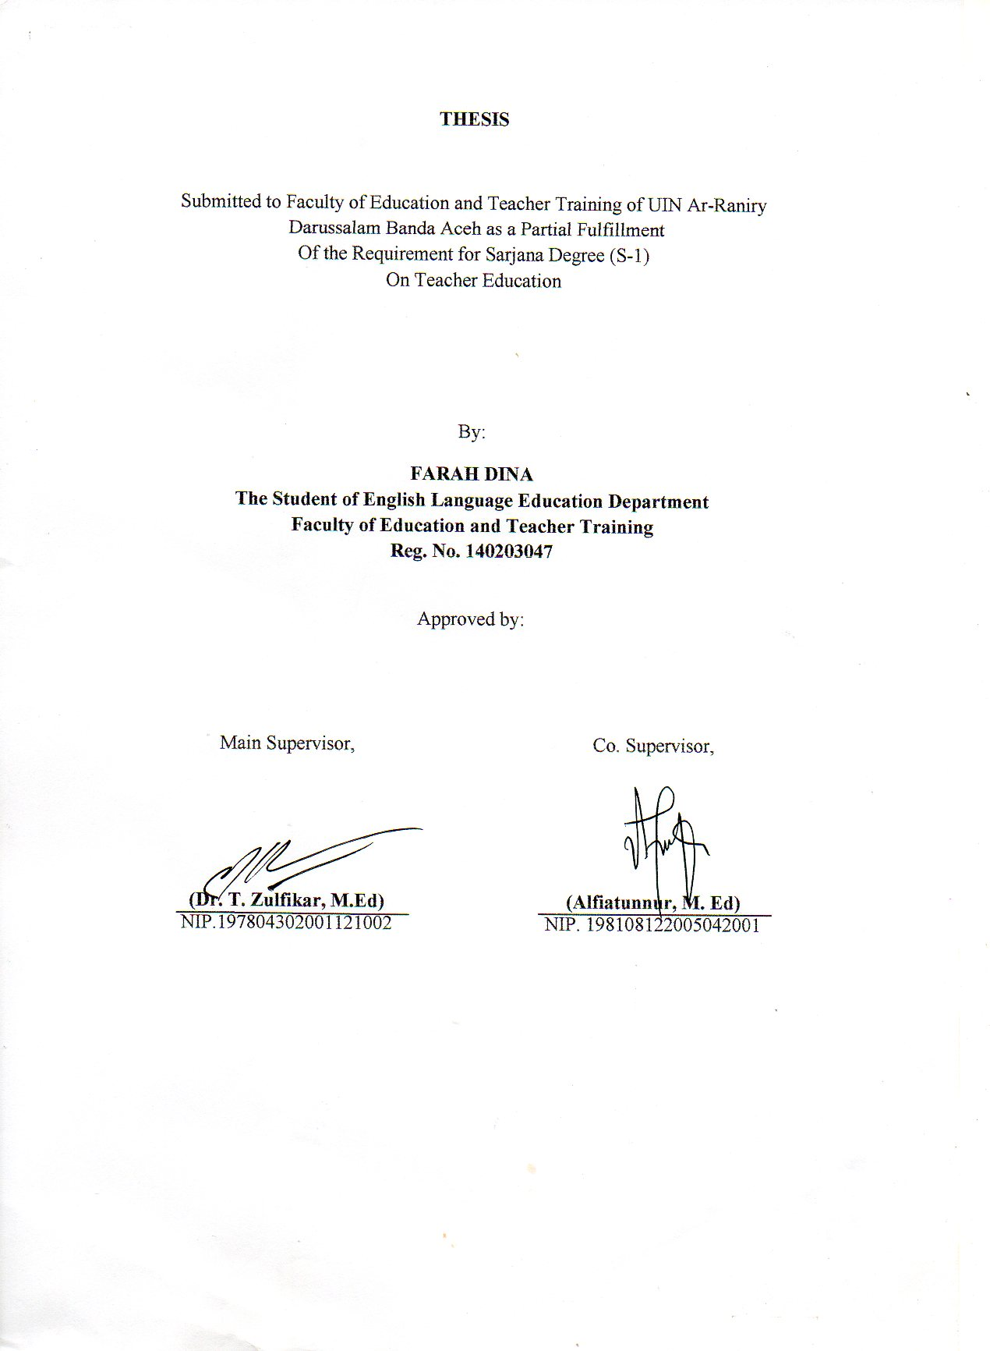

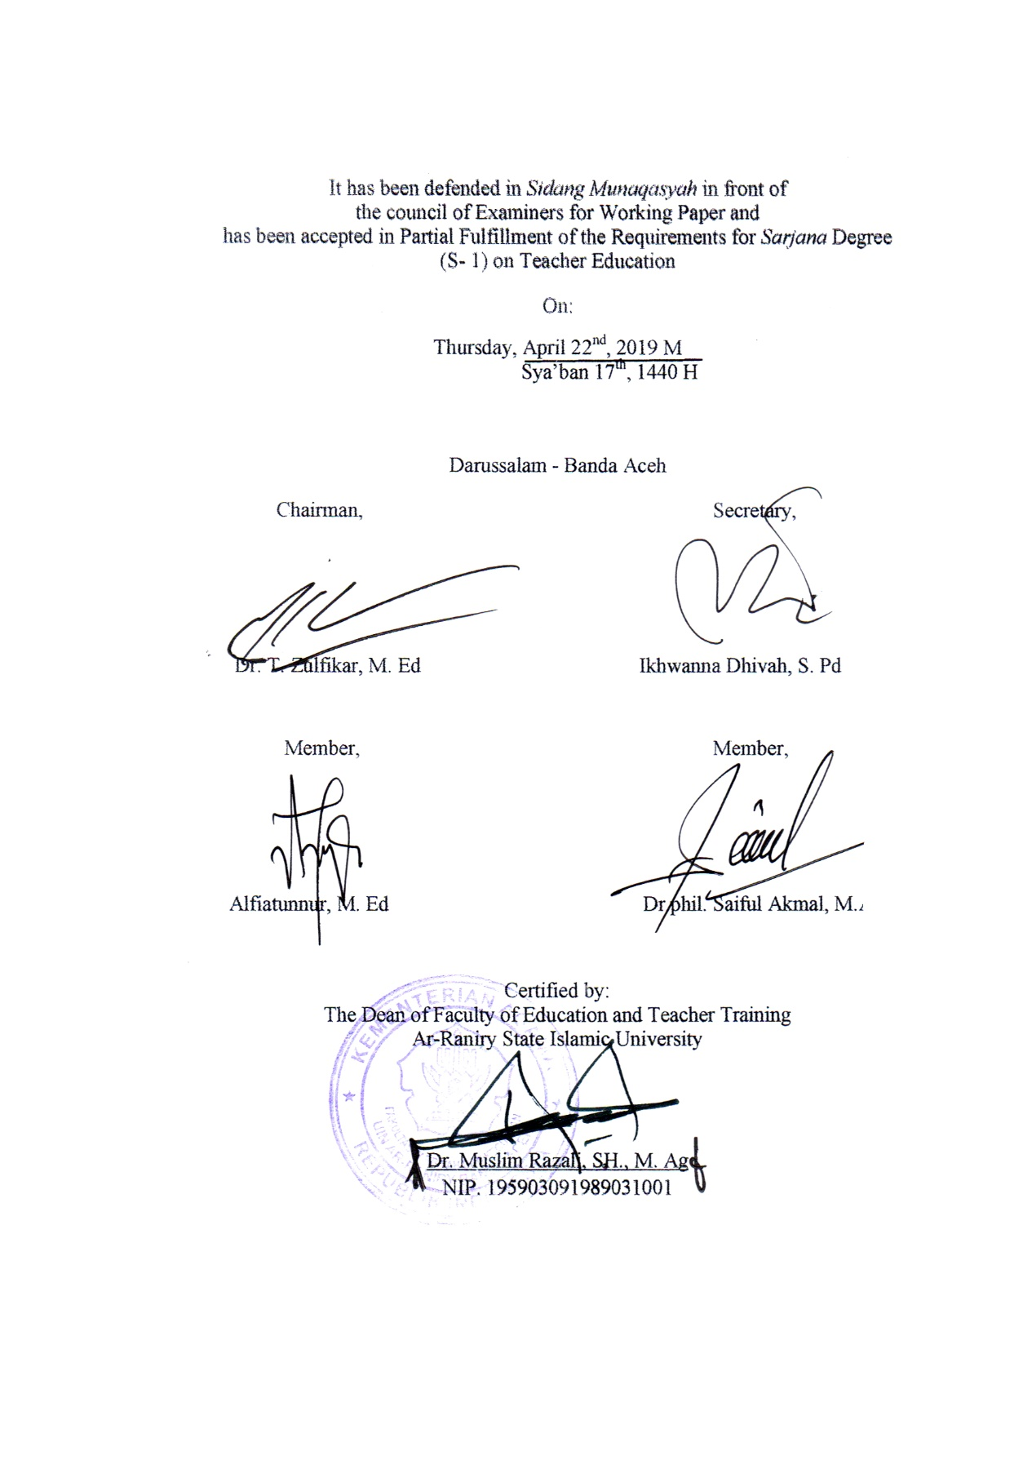

# **DECLARATION OF ORIGINALITY**

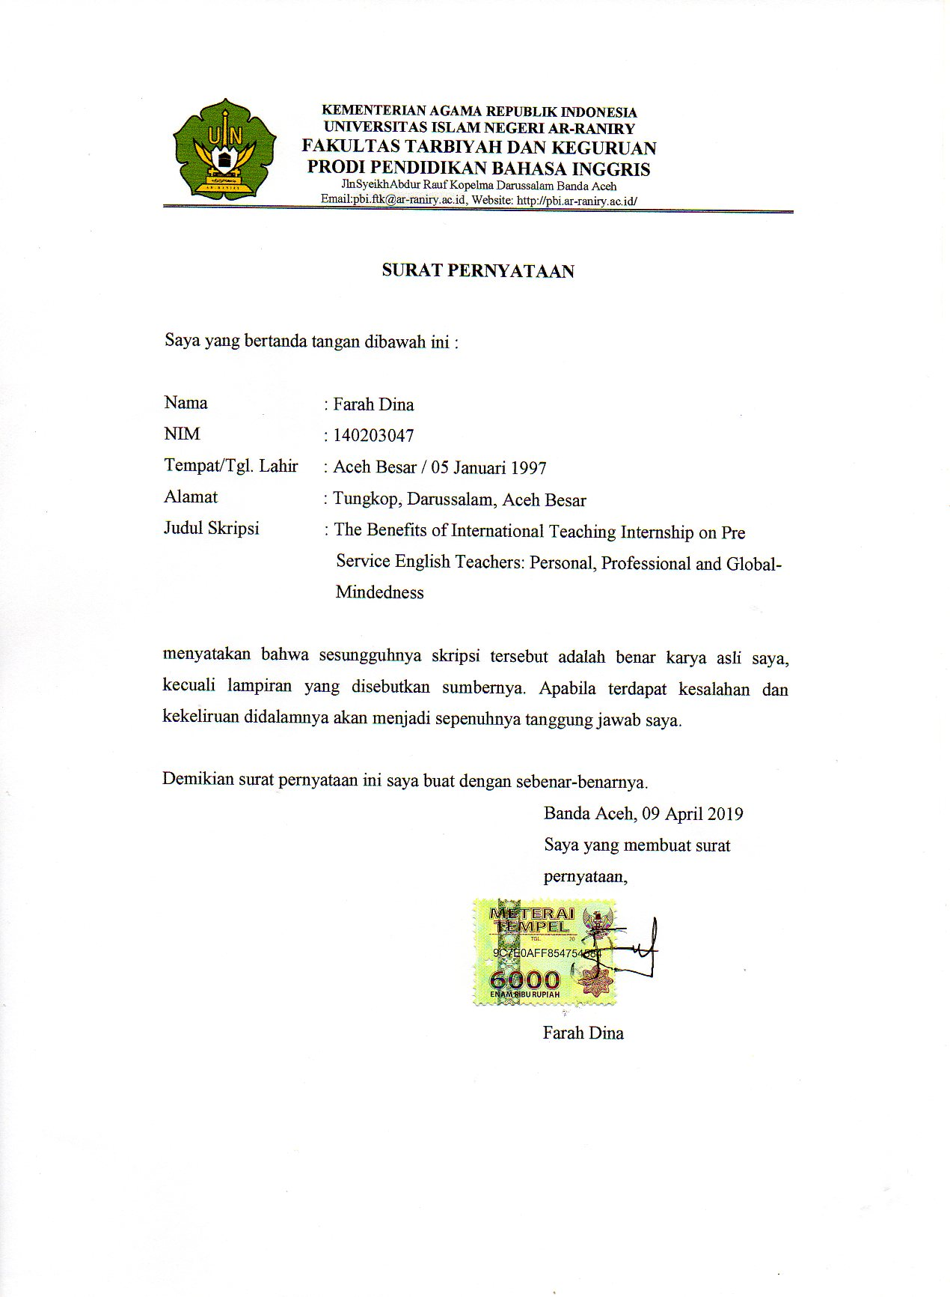

# **ACKNOWLEDGEMENT**



First, all praises to Allah SWT, the Almighty, the Most gracious, the Most Merciful who always gives me blessing, health, knowledge and strength. Peace be upon Prophet Muhammad SAW, together with his family and companions who struggled to bring us the *ummah* to the right path.

I would like to express appreciation for my supervisors Dr.T. Zulfikar, M.Ed., and Alfiatunnur, M.Ed. for the help, advise, encouragement, and feedback throughout the writing of my thesis. My gratitude is also addressed to all English Language Education lecturers and staffs who have given me knowledge, guided and helped me during my study in this department.

This journey would be impossible without the support of my family. A special gratitude, I would like to address to my beloved father, Tarmizi Dahmy, and my dearest mother, Maryana,. My parents are indeed my forefront supporters who prayed, encouraged and motivated me a lot not only in writing thesis, but all of good things I have achieved in my life. My appreciation is also extended to my siblings, Zahrul Fuadi, Ulfa Fajrina, Fadhli Ramadhan, Farrah Meutia and Nelis Sa’adah as well as to my nephew and nieces who join my parents in my life’s forefront supporter.

Abundant thanks go to my best facilitator and inspirator, Edwin Leo Mokodompit who has mentored me to achieve many things and supported me. I am also grateful for my best friends Tiara, Dessy, Miftah, Rahayu, Nisrina, Cut Jannat, Yusra, Rahmah, Dian, Dinda and Hafidh Ilmi for always helping me and for the good memories we have in college. I would like to express gratitude for Riki whose experience inspired me about the topic of this thesis. My special mentions are for my Man Model’s best friends Lissa, Upa, Riska, Laena, Laeni, Aiya, Tari, Hervi, Mita, Emier, Mukh, Noe, Oja and my close circle besties, Nora, Mia, Intan, Atis, Dira and Neny who always be with me in my happy and sad times. I would also give special credits for my inspiring friends in PCMI Aceh, Rizky, Aris, Ilham,Nurul and Siti. The special thanks also go to Kak Hafni and Calitra team for always be there to encourage me. My recognition is also for all of my research participants who helped me in conducting this research. Thanks for my other support systems UNIT 02, XL Future Leaders, IKYEP family, PCMI Aceh, Aikuna, Man Model, Turun Tangan, Kophi Aceh, CAMP EPIC, APUFY friends and PBI friends.

Finally, due to the shortcoming of this study, suggestions and comment are really meaningful in order to reduce its weakness and improve the quality of the writing. I hope this thesis will give valuable contribution for the readers.

Banda Aceh, March 31st 2018

Farah Dina

# **ABSTRACT**

Name : Farah Dina

Reg. No : 140203047

Faculty : *Fakultas Tarbiyah dan Keguruan*

Major : Department of English Language Education

Thesis working title : The Benefits of International Teaching Internship on Pre-Service English Teachers: Personal, Professional and Global-Mindedness

Main Supervisor : Dr. T. Zulfikar, M.Ed

Co Supervisor : Alfiatunnur, M.Ed

Keywords : *International Teaching Internship, Personal, Professional, Global-mindedness.*

This present study aims to investigate the benefits of international teaching internship named ‘Sea-Teacher’ program on Indonesian pre service English teachers’ personal, professional and global-mindedness development. There were 8 participants from Sea-Teacher program consisted of 4 males and 4 females participated in in-depth semi-structured interview. The researcher found out that there are three personal benefits of international internship, namely self-dependent, coping mechanism and time management; five professional benefits of international teaching internship, specifically confidence in speaking, teaching skills and ideas, new world views on education and culture, career goals and new opportunity; and the benefits of the development of global-mindedness., those are understanding different culture, strengthening global-networking and promoting respect.

# **TABLE OF CONTENTS**

DECLARATION OF ORIGINALITY iv

ACKNOWLEDGEMENT v

ABSTRACT vii

TABLE OF CONTENTS viii

LIST OF TABLE x

LIST OF APPENDICES xi

**CHAPTER I INTRODUCTION**

A. Background of The Study 1

B. Research Questions 5

C. Aims of the Study 5

D. Scope of the Study 5

E. Significance of the Study 6

F. Terminologies 7

**CHAPTER II** **LITERATURE REVIEW**

A. International Teaching Internship 9

B. Pre-Service Teachers 12

C. Personal Benefits of International Teaching Internship 13

D. Professional Benefits of International Teaching Internship 16

E. Global-Mindedness in International Teaching Internship 21

**CHAPTER III RESEARCH METHODOLOGY**

A. Research Setting 24

B. Research Design 26

C. Research Participants 27

D. Method of Data Collection 28

E. Methods of Data Analysis 29

**CHAPTER IV FINDING AND DISCUSSION**

A. Research Findings 30

B. Discussion 46

**CHAPTER V CONCLUSION AND RECOMMENDATION**

A. Conclusion 51

B. Suggestion 53

**REFERENCES 55**

**APPENDICES**

**AUTOBIOGRAPHY**

# **LIST OF TABLE**

Table 3. 1 The Sea Teachers' Participants in Each Batch 25

# **LIST OF APPENDICES**

Appendix A Appointment Letter of Supervisor

Appendix B Interview Instrument

Appendix C Explanatory Consent

Appendix D Consent Form

# **CHAPTER I**

**INTRODUCTION**

This part of chapter presents background of the study, research questions, aim of the study, scope of the study and significance of the study.

1. **Background of The Study**

The opportunity to get exposed to multicultural society in this era is much higher compared to what it was used to be in the past. In today’s world, accessing to multicultural society is as easy as browsing on internet and social media from any smart-devices. Through smart devices, people can communicate, learn, and exchange ideas with other people from different part of the world. This new connecting way also opens new opportunity in finding work. People from every country in this world nowadays get the same opportunity to acquire the job.

Not to mention, there are many opportunities created by international organizations to engage the world citizens. One of them is ASEAN Economic Community (AEC). AEC is created with the goal to promote economic, political and social-cultural cooperation across 10 member states in South-East Asia (Lehmacher, 2016). One of the policies that motivates ASEAN citizens to participate is the free flow of labours. With this free flow, workers compete not only with people from their own country, but also with other citizens of ASEAN countries in order to get the job.

The opportunities explained above should be noted as a reminder for all of world citizens that certain skills and competencies should be prepared earlier in order to survive in global workforce. The proper time to prepare the citizens is in university level. One of the ways to prepare the students to be able to enter the global workforce is by international internship.

The international internship could be an important component of Global Workforce Development (GWD); the perfect solution for gaining experience in the practical application of skills as well as building the global or intercultural competencies seemingly desired by employers across industry types and fields (Malerich, 2009, p.5)

The international internship does not only provide opportunity for students to apply their professional skills, but build their intercultural skill as well. Moreover, Chen et al. (2011) stated that in internship, students will have the opportunity to discover their job interest and also received comments to develop themselves from their mentor. With the benefits mentioned above, it is important for students from any major to learn and participate in international internship.

Internship is also an indispensable part for students in teacher education program (Posner, 2005) and International internship is important for students who in the future want to be English as a Second Language (ESL) teachers (Chi, 2011). In addition, internship also challenges the future teachers the ‘real world’ of classrooms to improve their teaching skills (Willhite, Mclntyre, & Willhite, 2008 as cited in Yang, 2011). Brindley et al. (2009) suggested that a teaching internship program can ‘act as a catalyst’ for pre-service teachers’ professional development. It gives the earlier preparation for the student teachers to be more professional before they are in the real workforce.

There are number of previous studies which proved that international internship for pre-service teachers provided a lot of benefits in many aspects. Willard (2001) stated that student teachers demonstrated “personal growth”. Moreover, Cushner and Mahon (2002) who explored the effects of international internship on 50 US student-teachers who took their teaching practicum in some different countries such as Australia, Ireland and New Zealand highlighted personal benefits from teaching experience on beliefs about self and self-efficacy.

Stanley (2010) noted three professional benefits of US students-teachers in their teaching practicum in Belize, those are impact on creativity, impact on flexibility and Impact on confidence. Kabilan (2013) investigated 6 student-teachers from School of Educational Studies Universiti Sains Malaysia enrolled on teaching practicum in Maldives about their professional development during the programs. On the findings, he highlighted five points as follows: confidence in speaking and communication, teaching confidence and skills, interpersonal skill, new views about education and culture and adapting to new working cultures.

On global mindedness, Lee (2011) who studied seventeen Hongkong student teachers’ internship in New Zealand found out that the experience provided the participants the learning about culture. Through the program, they became more appreciative toward the culture and life of New Zealand people. Stanley (2010) who studied about impact of international student teaching experience on 18 pre-service teachers in third world country stated that it had a good impact on global awareness.

While reviewing the previous studies about the effects of international internship on teacher candidates, the author found many studies about this topic on teacher candidates from other countries like Yang (2011) who studied about Canadian teacher candidates’s teaching practicum in Hongkong or Lee (2011) who examined international field experience on Hongkong student teacher’s joining a program in New Zealand or Cushner and Mahon (2002) who studied the impact of international teaching internship on 75 American students joining Consortium for Overseas Student Teaching (COST) program which placement took place in many countries like Australia, New Zealand, England, Ireland, Greece, Japan, Mexico, Switzerland and Turkey . However, there were still limited researches about the impact or the benefits of international teaching internship program on Indonesian pre-service teachers.

Therefore, this present study aims to investigate the benefit of international teaching internship named ‘Sea-Teacher’ on Indonesian pre service English teachers’ personal, professional and also global-mindedness development. The SEA Teacher Project or the “Pre-Service Student Teacher Exchange in Southeast Asia” is a program that has purposes to provide opportunity for pre-service student teachers from universities in Southeast Asia to have teaching experiences (practicum) in other countries around Southeast Asia.

1. **Research Questions**

Based on the background above, this research attempts to find out these questions:

1. What benefits do pre-service English teachers gain during their international teaching internship in terms of personal development?
2. What benefits do pre-service English teachers gain during their international teaching internship in terms of professional development?
3. What benefits do pre-service English teachers gain during their international teaching internship in terms of global mindedness development?
4. **Aims of the Study**

Corresponding with the research questions, the aims of this research are:

1. To explain the benefits that pre-service English teachers gain during their international teaching internship in terms of personal development.
2. To explore the benefits that pre-service English teachers gain during their international teaching internship in terms of professional development.
3. To investigate the benefits that pre-service English teachers gain during their international teaching internship in terms of global-mindedness development.
4. **Scope of the Study**

The research explores the impact of international Pre-Service Teaching Internship named Sea-Teacher program. It will be limited to only Pre-Service English Teachers who joined this program in the fifth batch and sixth batch. The batches were chosen considering that these were the most recent ones, so the participants in this research may provide the most relevant information. The writer focuses to study about how the program benefited them to develop their personal, professional life and global mindedness skill.

1. **Significance of the Study**

This research is hoped to give significant benefits to these particular parties.

1. English teacher training students

Living in a globalization era, students need to be prepared on both soft skills and hard skills in order to face the competition in global workforce. One of ways to have an earlier preparation is by joining international internship. The results of this research are hoped to give English teacher candidates insight about teaching experience abroad and motivate the students to join that kind of program. In addition, students who do not have the international teaching internship yet can learn from the other students’ experiences by reading this research.

1. Lecturer

Lecturer are responsible to provide and facilitate learning to their students. The author hopes that the results of this research may add more information to lecturer about how important international exposure in this era for students and provide them with more multi-cultural learning. Besides providing and sharing information about international internship, the other possible solution is by using technology. The lecturer may use web-based media to facilitate the communication between their students and foreign school students.

1. Stakeholders in University

The data gathered in this research may help the design of international teaching internship program in many universities. It is also hoped that the results will trigger the stakeholders in universities to gain more collaboration and cooperation with universities abroad, so that more exchange opportunities for students, lecturer and staffs may be achieved.

1. **Terminologies**

To avoid misinterpretation of this writing, it is important for author to clarify some terms as follow:

1. International Teaching Internship

For this research, the author defined international teaching internship as the teaching practicum enrolled by Indonesian English department students in an international setting outside of Indonesia. The overseas teaching program intended by author in this research is The Sea Teacher Project or also called as ‘Pre-Service Student Teacher Exchange in Southeast Asia held by SEAMEO cooperating with schools and universities in Southeast Asia countries.

1. Pre-Service Teacher

The intended definition for pre-service teachers in this study are students from English language education department of teacher training faculties from all around Indonesia who took teaching practicum under the program Sea-Teacher project.

1. Personal Benefit

This term in this research referred to the benefits that the student teachers had during the teaching program on their self-growth or self-development. It was usually shown by traits as confidence, self-efficacy, adaptability, independence etc. (Stanley, 2010; Cushner and Mahon, 2002; Egeland, 2016).

1. Professional Benefit

The professional benefit term was used in this research in order to explain the benefits that student teachers got during the program on their professional development to be ready for workforce. For example: confidence in speaking and communication, teaching skill, interpersonal skill, new views about education and adapting to work cultures (Kabilan, 2013).

1. Global Mindedness Benefit

Park et.al (2016) stated that global mindedness or also known as international mindedness was the ability to understand the world, fit in the world as well as take action on global problems.

**CHAPTER II**

**LITERATURE REVIEW**

This part of study deals with a description about relevant literatures. The chapter explains some components, those are international teaching internship, personal benefits of international teaching internship, professional benefits of international teaching internship, benefits of the development of global mindedness in international teaching internship.

1. **International Teaching Internship**

According to Araya (2013), teaching practicum is an organized program for pre-service teachers, in which student-teacher practices the learned skills they got from teacher training faculty in schools under the supervision of schools’ teachers. Masadeh (2017) defined practicum as a course in university which equips pre-service teachers with practical knowledge about real context of teaching. It also helps them to be familiar with teaching process and challenges. The practicum program provides the opportunities for student teacher to test their ability as well as learn from expert teachers’ experience.

There are many reasons that drive institutions or governments to do partnership and create international teaching practicum program, the first and the most popular one isbecause of globalization. Globalization is the concept of competitiveness in ‘world class’ (Moloi et al.,2009). Nowadays, teaching profession faces several challenges like the global economy, competitive market, advanced technologies and changes in demographics of students (Tuli and File, 2009). In the age of globalization, there is a great demand for teachers to have global knowledge and cross-cultural learning (Cushner and Mahon, 2002).

Therefore, Blair (2002 as cited in Shiveley and Misco, 2015) stated that teacher training faculty need to involve their students in international and global experiences, so that the future teachers would become more sensitive and understand diverse students that in the future will be found in many classrooms. Furthermore, as cited from Lee (2011), Heyl and McCarthy (2003) said that it is essential to graduate future teachers who think globally, have international experience, speak foreign language and can integrate a global dimension into teaching-learning process.

The other term referred as the reason of implementing international practicum program is borderless education. Borderless education is the development that crosses the traditional borders of education whether geographical or conceptual (Middlehurst, 2001). With the borderless education, it is believed that overseas partnership is significant in creating a better education.

Because of the reasons mentioned above, many institutions and governments were encouraged to create international practicum projects and gained significant values. Lee (2011) who studied Hongkong student-teachers who joined international teaching internship program in New Zealand for six weeks found out that the experience helped the participants to enrich cultural understanding, pedagogical knowledge and skill, language awareness and classroom language. On the other research, Yang (2011) interviewed seven Canadians who were enrolling on eight weeks teaching practicum in Hongkong about their perception on international teaching practicum program. He found out that teaching practicum helped the participants in improving their teaching ability as they got opportunities to observe the mentors as well get feedback from them. In addition, participants felt benefited from extra-curricular activities in school. By doing the activities, they felt as the part of the school communities and they had extra time to interact with students and understand their interest.

According to ‘Academic and Thesis Guide’ of Faculty of Education and Teacher Training Ar-Raniry State Islamic University (2016, p.5), the vision of the faculty is to “Become the educational institution and educational workers which are competitive, integrative, multidiscipline, professional and Islamic.” with the missions as follows:

1. Administer qualified academic activities and professional education with global-competitiveness.
2. Implement and develop research in the field of education and learning about local and multidisciplinary wisdom
3. Practice community services in the field of education and learning in formal and informal institutions of education.
4. Build partnerships with various institution in local, national and international level.

Considering the vision and the missions ,specifically about administering academic activities with global competitiveness and building partnership in international level, the faculty of education and teacher training Ar-Raniry State Islamic Universities need to consider to incorporate international teaching internship as one of activities as the mission to achieve the vision.

1. **Pre-Service Teachers**

Tuli (2009) stated that teachers are agents of change in society as they are the centre of education delivery. Because the teachers hold a very important role in society, it is crucial to prepare the future teachers professionally. Based on the statement above, it could be inferred that preparing future teachers will make changes in a society. It is one of the reasons why the teacher training or teacher education program exists. Araya (2013) believed that teacher training or teacher education is a core of any educational system. To support this idea, Tadesse and Meaza (2007) pointed that a well-designed teacher training program would produce teachers who are academically competent, professionally skilled and ethically committed to be teachers. Teacher training program has a major role in preparing the pre-service teachers.

The term pre-service teacher is also known as student-teacher or teacher candidate. It refers to college students who are engaged in an assigned student teaching internship (Johnson and Perry, 1967, as cited in Agustina, 2014). According to Instructional Development Center of Faculty of Education and Teacher Training Department of English Language Education of Uin Ar-Raniry (2017), pre-service teachers are students in teacher training faculty wo are trained to be professional teachers in schools. To sum up, pre-service teachers are student teachers who are enrolled in a teacher education program and have to take teaching internship program. They will do field-based teaching experiences supported by mentorship. It is a compulsory for them to take teaching practicum as a requisite course for them to graduate from their university.

Before doing the practicum, they were trained in university. The student teachers are trained professionally in teacher training faculty so that they can be confident and knowledgeable about teaching practice and able to teach in various setting. They learned about theories of teaching in teacher training faculty then practice their teaching skill in the school as a requisite course to graduate.

1. **Personal Benefits of International Teaching Internship**

There are many researchers who have focus on the personal benefits of international teaching internship. Stanley (2010) who studied 17 participants from the United States taking international internship in Belize. On her findings, she mentioned about personal developments that pre-service teacher gained during their internship, as follow:

1. Adaptability

As they encounter new people and new culture, the participants learn how to adapt and adjust. This trait was shown as they braced themselves to try and adapt with Belizean’s food and they taught students with different backgrounds. They learned adaptation skill in order to survive. This skill later on will be beneficial for their own life in surviving fast-changing world.

1. Empathy

During the practicum program, they experienced how the feeling of being minority. As the result they build emphatic towards the minority in America.

1. Personal growth

In the practicum program, participants mentioned that they were interested and built commitment in joining social and cultural activities in Belize. Several participants were also interested in to learn local language.

On the other research conducted by Pence and Macgillivray (2007), 15 pre-service teachers from US completed their 4-week international practicum in Rome, Italy. The findings showed the personal benefits as it increased confidence. Ellen, one of participants, mentioned that she noticed herself becoming more confident both in classroom and in herself, the other participant, Katherine, said that she become more confident and stronger person as a result of teaching internship experience. She received many feedbacks and supports from her mentor that boost more her confidence. The other personal benefit that they gained was tolerance or appreciation for diversity. Andrea stated that Rome changed himself in a way he could understand and appreciate different types of students. Alisa told the interviewer that through her reflection in practicum program, she gained respect for those who came to US and could not speak English because she had experience being minority.

Cushner and Mahon (2002) who explored the effects of international internship on 50 US student-teachers who took their teaching practicum in some different countries such as Australia, Ireland and New Zealand highlighted personal benefits from teaching experience on beliefs about self and self-efficacy. Self-efficacy is a person’s belief that they can be successful when carrying out a particular task (“Self-efficacy”, n.d). One of the participants stated that he was the only African-American in that school community. He was scared, but he was confidence and believed that he could get through that and be independent.

In Egeland’s (2016) research, he explored the impact of overseas student teaching. The benefits that he found on personal cultural perspective were on confidence and independence. Living abroad means living away from family, friends and other support systems. Through this opportunity, student-teachers learn how to rely on themselves, develop practical skills, and decide independent decisions. One of the participants, Kaitlynn, mentioned that she had to learn how to live on her own, how to cook and how to manage her own financial. Whitney added that the practicum experienced had her to leave her comfort zone and be dependent.

Pilonieta et.al (2017) who studied about the impacts that North Carolina teacher candidates got during their teaching internship Germany schools highlighted coping mechanism as personal benefit. Pre-service teachers found coping mechanism to handle barriers, especially language barrier, for example one of the participants did not know how to read menu in a Germany restaurant, he ended up using visuals, body language and even some terms in German to cope with this challenge.

1. **Professional Benefits of International Teaching Internship**

One of well-known research about professional benefits of international internship is from Kabilan (2013). He investigated six student-teachers from School of Educational Studies Universiti Sains Malaysia enrolling on teaching practicum in Maldives about their professional development during the programs. On the findings, he highlighted five points as follow:

1. Confidence in speaking and communication

The participants stated that teaching practicum made them to be more confident in using English in speaking and communicating. They said that there was no opportunity for them to speak Malay as they had to deliver and gave instructions to student in English as well as talked with other staff.

1. Teaching confidence and skills

Participants had noted that there were significant changes on their teaching confidence and skills. As participant Y said that she improved in lesson planning. She stated that she used her creativity in making lesson plan. She incorporated some games and activities in the lesson plan in order to make Maldivian students more interested. By doing this, she gained confidence.

The other participant improved in time management in class. Teacher S mentioned that before teaching practicum, she always failed managing time in class. However, during international practicum, her mentor acknowledged her weakness and offered her solutions to the problem.

1. Interpersonal skill

Some participants believed that international teaching practicum had helped them to increase interpersonal skills. As some participants said that their communication skills improved through frequent interactions with teachers, students, staffs with different races, cultures and identities. At first, they were afraid to communicate with foreign people. However, as the time passed, they overcame this challenge.

1. New views about education and culture

The participants argued that international practicum gave them new insight about global educational issues, other educational issues as well new knowledge about international practices. They got time to experience new syllabus and educational system. By that, they might compare both Malaysian and Maldivian approach to second language learning. Most of the participants preferred Malaysian approach and syllabus. However, they also acknowledged that some elements in Maldivians approach were more effective as participant A mentioned that Maldivian IGCSE syllabus did not only stimulate students thinking, but teacher as well.

1. Adapting to new working cultures

The participants believed that they learned how to adjust to new working cultures and condition. As participant Y stated that in Maldives, coordination meeting between subject teachers was held in order to provide best lesson for students. All teachers were given opportunities to give ideas about how to teach and what activities can be incorporated for next week teaching. It was different with what happened in Malaysia context and they were sure that this activity might help teachers in order   
to develop themselves professionally.

Stanley (2010) noted three professional benefits of US students-teachers in their teaching practicum in Belize, as mentioned below:

1. Impact on creativity

The participants acknowledged to be more creative in lesson planning. Because the lack of access to technology in Belize, US student teachers had to be creative in planning the class. Moreover, Belize was also limited in internet access, therefore they had to come up with the ideas from themselves.

1. Impact on flexibility

The flexibility was one of the traits they got during this internship program. They stated that they had to be prepared for the unprepared. For example, one participant had prepared the power point slides for the class, however when the class started, the electricity suddenly went off. They had no choice except to be flexible and came up with other solutions.

1. Impact on confidence

The teaching internship had impact on the student teacher’s professional confidence. One of participants mentioned that the program changed her a lot. She acknowledged to be more confident in managing the class. The researcher mentioned that when in Belize the student teachers felt like they were accountable for themselves, not to impress others. Therefore, they really felt the experience being a teacher, not student teachers. It was a trigger for them to be more confidence in teaching.

Rodriguez (2011) whose research on the US student teachers’ learning through their international teaching internship of in Bolivia stated that “the line between personal and professional is completely blurred” (p. 295). These two items were both essentials to be mentioned in explaining about the benefits of international teaching practicum. He added that most of participants in his research points out similar answers between these two items. The experience helped the participants to understand their role as a teacher. Through this internship, they learned how to respect all the students with different cultural background. A participant mentioned she learned that teaching in poor country did not necessarily mean to teach them differently, but several strategies need to be incorporated in order to be more effective.

Furthermore, Ateskan (2016) whose research aimed to explore Turkish student teachers’ international teaching experience in Ames, Lowa mentioned these things as the benefits which the chosen themes were similar to the findings’ themes from Kabilan (2013) who studied Malaysian student teachers’ internship in Maldives. The benefits of Ateskan’s research as follows: The first point is confidence in communication. Ateskan’s participants mentioned that they also gained confidence in speaking and communication in practicum. They highlighted that American’s students and mentor were really appreciative and tolerant. In mentor journal, it was mentioned by the mentor that most of them successfully became more confident at the third week of practicum. The second is the confidence in teaching. They observed the mentor classes and they became familiar with the mentors’ approach in class. It helped them to become more confidence in Teaching. The third is interpersonal skills. They improved this skill through regular communication with teachers, students and staffs. They escalated the experiences through attending department meeting, receiving training and presenting at parent conference.

The next point mentioned by Ateskan (2016) was new world views about education and culture. Participant 4 notes that through international practicum, she had the opportunity to experience education in other country and culture, through that, she gained new worlds view so she could compare and realize the benefits and challenges of education. She reported that in Turkey, students had their own room and teacher had to move from one class to another class. However, in the US, the teachers had their own room with resources and the students had to move from one class to another classes. This thing affected in the resources in the class. US teachers had their own complete resources in class and did not have to move all of them while Turkish teachers need to bring the resources from one class to another. The school’s policy in US had expanded student’s opportunities to learn using technology. The last point is the benefit of adapting in new working culture. Throughout the teaching practicum in US schools, the Turkish pre-service teachers practiced and learned working in new setting. They learned the behaviour of students and adapt with it. Most of students in Lowa were more mature than students in Turkey. The majority of US students had part-time or volunteer jobs.

1. **Global-Mindedness in International Teaching Internship**

Park et.al (2016) stated that global mindedness or also known as international mindedness was the ability to understand the world, fit in the world as well as take action on global problems. Sutcliffe (2012) mentioned that teaching and fostering international mindedness skill for students was important as we live in a globalized world. When a person has this ability, he or she would likely engage actively in participating to solve world’s problem.

Savage (2017) added that International mindedness facilitated people to work in harmony, promotes respect, strengthen networking as well as grow empathy. In addition, she said that there were seven indications of a global mindedness person, those were understanding of different cultures, self-awareness, empathy, capability to work with people from different backgrounds, increased understanding about international issues, being a responsible global citizens and language skills. Cushner (2007) said that there were some ways to increase this international minded competence, those were by watching movies, listening to foreign speakers, discussing about cultural differences issues and also experience. Therefore, there have been a lot of universities and institutions that incorporated their pre-service English teachers with international teaching practicum experiences.

Cushner and Mahon (2002) studied about overseas student teaching by examining fifty US student teachers who had participated in student teaching program in some countries with the majority of them in Australia, Ireland and New Zealand. He found out that international teaching practicum brought positive impact on student-teachers global mindedness skill. Some participants mentioned that they knew more about world event and less ethnocentric, they also became more multicultural in their view about the world. One participant also mentioned that the experience helped him to look back of their own culture and reflect as he said that he thought that he felt more accepted as African American rather than in his own countries.

Lee (2011) who studied seventeen Hongkong student teachers’ internship in New Zealand found out that the experience provided the participants the learning about culture. Through the program, they became more appreciative toward the culture and life of New Zealand people. For example, Rita and Christie noted that New Zealand people had a big concern toward environments. Because of that they became more aware to protect the environment, Christie even promised to save water and electricity as the result of her experience. May and Ann mentioned that they were more open minded as they had exposure of New Zealand multicultural society. They developed acceptance ability of other people for things like value system, living style, religion and food.

Stanley (2010) who studied about impact of international student teaching experience on 18 pre-service teachers in third world country stated that it had a good impact on global awareness. A participant, Sara, shared that it was the first time for her being in third world country. She had been watching how living in third world country in television. She used to get abstract feeling. She felt sad but not really into it. However, when she went there, she got the real feeling. She wanted to help the Belize people, send supplies and resources. Her willingness to help became bigger and stronger. She concluded that the experience helped her to expand her worldwide view.

**CHAPTER III**

**RESEARCH METHOD**

This chapter presents the descriptions of the research setting, research design, research participants, method of data collection and method of data analysis.

1. **Research Setting**

The international practicum was named ‘Sea Teacher Project’ or the “Pre-Service Student Teacher exchange is Southeast Asia”. The program is managed by Southeast Asian Ministers of Education Organization (SEAMEO). SEAMEO is a regional intergovernmental organization that was established in 1965 among governments in Southeast Asia countries to promote regional cooperation in education, science and culture in the region.

SEAMEO has 7 priority areas in the year of 2015-2035, those are early childhood care and education, addressing barriers to inclusion, ensuring resiliency in the face of emergencies, promoting technical and vocational education and training, revitalizing teacher education, promoting harmonisation in higher education and research and adopting a 21st century curriculum. Based on the point of revitalizing teacher education in SEAMEO priority areas, this organisation created Sea Teacher project for building and strengthening capacity of teacher in regions.

The teaching practicum ‘Sea Teacher’ requires last year students (on the third or fourth year) to participate in the program with good English skill for communication purpose. The student teachers that might join were students from major of math, science, English and pre-school. The duration of the practicum was one-month and based on cost sharing. The student teachers’ role during one month were observing, assisting in teaching, teaching and reflecting. While the host universities roles were to provide mentor, supervise and monitor the pre-service teachers during the practicum.

Starting the first batch in 2016, in 2019, Sea-Teacher project already had seven batches participating in the program. Six batches had completed their program and the seventh batch were still undergoing the program, the explanation as follow:

Table 3. 1

*The Sea Teachers' Participants in Each Batch*

|  |  |  |  |  |  |
| --- | --- | --- | --- | --- | --- |
| **Batch** | **Time** | **Students** | | | **Participating Universities** |
| **Indonesia** | **Philippine** | **Thailand** |
| 1st batch | 20 Jan- 18 Feb 2016 | 12 | - | 10 | 2 |
| 2nd batch | 17 Jul-15 Aug 2016 | 56 | 5 | 40 | 7 |
| 3rd batch | 15 Jan-13 Feb 2017 | 89 | 26 | 81 | 27 |
| 4th batch | 7 Aug-5 Sep 2017 | 132 | 52 | 81 | 41 |
| 5th batch | 22 Jan-18 Feb 2018 | 170 | 110 | 92 | 57 |
| 6th batch | 1 Aug-10 Sep 2018 | 207 | 133 | 84 | 79 |

This program aims to provide opportunities for student-teachers from universities in Southeast Asia to have international teaching practicum in schools in Southeast Asia. There are 4 objectives of the project as (1) to enable pre-service student teachers to develop their teaching skills and pedagogy (2) to encourage the pre-service student teachers to practice their English skills (3) to allow the pre-service student teachers to gain a broader regional and world view (4) to expose future teachers to diverse teaching and learning situations and opportunities, and the value of flexibility (SEAMEO, 2016)

1. **Research Design**

In this research, the benefit of international teaching practicum on pre-service English teachers on the participant’s personal, professional life and global mindedness were intended to be explored. Therefore, qualitative method was employed. Creswell (2012) stated that qualitative research was best used when the researcher did not know the exact variables to explore. The literature reviews did not play as essential role, but it helped to yield the information about the phenomenon. What matter the most in qualitative research was the view of the participants about the study.

Specifically, narrative research design was used in this research because this research was attempted to analyse the phenomenon based on the view of chosen participants by asking them several question in order to gather the data and then present the analysed data (result) into form of words. According to Creswell (2012), narrative research design was employed when the researchers reported the participants’ life stories. He added that there are several characteristics of narrative research as (1) it explores individuals’ experiences, (2) it reports the chronology of ones’ experiences, (3) it collects individual stories, (4) the researcher narratively retells the story, (5) narrative researcher code the data into themes, (5) researcher incorporates context in the narrative and (6) researcher collaborates with participants in inquiry process.

1. **Research Participants**

In this research, the researcher utilized purposive sampling to select the participants. According to Arifin (2012), purposive sampling is sampling technique based on consideration of certain aim and on certain criteria or characteristics that have been set beforehand. Creswell (2012) added that with the purposive sampling, the researcher chose the participants intentionally with the standard that the participants were information rich about the topic researched. It could be concluded that certain criteria and standard needed to be set to get as many as information from the participants.

Purposive sampling was employed because the researcher set certain criteria in choosing the participants, those are, the participants were from English education department in Indonesia universities, the participants took teaching practicum in Sea-Teacher program and the participants were enrolled on 5th or 6th batch of Sea-Teacher program. With the set criteria, the researchers contacted the possible participants to ask their consent and found 8 people willing to participate from English department of universities all around Indonesia, specifically from Universitas Syiah Kuala, Universitas Negeri Surabaya, Universitas Muhammadiah Sumatra Utara, Universitas Halu Oleo, Universitas Sebelas Maret, Universitas Muhammadiah Purwokerto, STIKIP Muhammadiah Kotabumi and Universitas Bengkulu. The participants consisted of four males and four females with five people from 6th batch and 3 people from 5th batch.

1. **Method of Data Collection**

Technique of data collection guided the researcher systematically in collecting the data needed in this study. The author used one data collection procedure, that is interview. Interview is conversation between interviewer and interviewees whether direct or indirect to achieve certain purposes (Arifin, 2012). According to Warren and Karner (2015) there are 5 types of interview, those are, structured interview, semi-structured interview, unstructured interview, informal interview and focus group discussion. In this research, the interviewer utilized semi-structured interview. In semi-structured interview, there were predetermined questions, but the interviewer could ask the participants clarifications and also follow up questions (Griffe, 2012).

Before collecting the data, the researcher modified the instrument and did the prototyping. The prototyping was done by testing the instrument on the alumni of the sea teacher program from math subject with the goal to find whether the questions were agreed with the situation of the program. Afterwards, the interviewer called the participants one by one through phone call with duration 20 minutes on average. The interview process was proceeded through phone call because most of the respondents lived in different provinces of Indonesia. Creswell (2012) confirmed that phone interview allows the researcher to easily access the information from participants when both have geographical barrier. However, the weakness is that the researcher cannot see non-verbal communications from the interviewees. During the interview, the researcher recorded all the talk through phone recorder.

1. **Methods of Data Analysis**

After all the data have been collected, the next step to do is analyzing the data. Bakri (2003) pointed out that data analysis is a process of reviewing, writing and grouping the data in order to formulate theories in research finding. In short, data analysis is following certain procedures to process the collected data with the aim to answer the reasearch question that will be presented in the finding parts.

To analyze the data gathered, the researcher adapted the steps from Hycner (1985) as cited in Cohen et al. (2007). The first step was the transcription of the recording, then the process would be continued by bracketing and phenomenological reduction, third was listening to the interview for a sense of a whole, then eliminating redundancies, the next step was clustering units to relevant meaning and the last was composing the summary.

# **CHAPTER IV**

**FINDINGS AND DISCUSSION**

This chapter presents the results of data interview analysis. This study aims to explain the benefits pre-service English teachers gain during their international teaching internship in terms of personal, professional and global-mindedness development.

1. **Research Findings**

The following responses of the interview were the result of the research. In this research, there were 8 participants from Sea-Teacher program consisted of 4 males and 4 females. 3 participants were alumni in the fifth batch and the other 5 were alumni in sixth batch of Sea-Teacher.

As described in previous chapter, the technique of data collection used was semi-structured interview. There were seven main questions and several follow-up questions. After analyzing the data, the researcher presented these points:

1. ***The Benefit on Personal Development***

Based on the result of interviews, the benefits of international teaching internship on personal development of student teachers are divided into three categories, those are the benefits on self-dependent, coping mechanism and time- management.

1. **Self-dependent**

Most of pre-service teachers on this research mentioned that the international teaching internship affected their independency. During the international teaching internship, the participants lived in other country and was away from their parents for one month. The situation forced them to be more capable to do things by themselves and not rely on others too much. As the participant C said:

It makes me really independence because before that my mom cooked everything for me or I bought something in the shop. But since being there, many foods are not halal so I had to cook by myself or by my friends. And like wash the dishes, wash everything and do everything by myself.

In similar way, participant G believed that the experience living in other country affected her to be more independent and gained practical life skills. Because of the situation, she had to manage her own need by herself, as she mentioned:

I have never gone that far from my parents. It influenced my life skill, it helped me to maintain how I wash my clothes, washed the dishes, what time I should go on foot, because I went by foot everywhere, I had no motorcycle there, so I had to go by foot, or I took public transportation.

The data showed that the international teaching internship benefited the pre-service English teacher on independence. They did not rely on others and fulfill their own needs to survive. The result was similar to Egeland (2016) who found out that through international teaching internship, student-teachers learned how to rely on themselves, developed practical skills and decided independent decision.

1. **Coping Mechanism**

The result of the research showed that pre-service teachers develop coping mechanism during international teaching internship. They were able to handle barriers and had problem solving skill as they encountered problems and challenges during the program, especially the language barrier. For example, the student-teacher did not know how to find *halal* food. He did not just stay still, instead he made friend with Thailand people, so they could help him to communicate with local. As the time passed by, he escalated his coping mechanism by learning Thai language in order to make him easier to communicate with local. As the participant A mentioned:

On the first week, I met some difficulties especially on finding food because you know, Thailand had a lot of pork. So I got buddies from the university that helped me to find some halal foods and find some *Masjid* (mosque) and something else. Then on the second week and the next third week, I learned the culture from the circumstances. For example, when I bought something, I learn to say it with Thai language and then my buddies helped me to speak basic conversation in Thailand, for example how to deal with the people, how to greet people, how to say number and then I can use the experience to buy something and greet people.

Participant F also developed coping mechanism as he faced a cultural misunderstanding problem in Thailand. He unintentionally wore bright color cloth when the King in Thailand had just passed away which could be interpreted as an impolite manner. As the result, the old men yelled at him. However, he did not understand what the old man said. He solved this problem by asking his Thai friend to say sorry to the old man and decided not to wear bright color anymore in public, as the participant F said:

I was surprise, I told my friend to say sorry for him in Thailand, because I could not speak Thai, but then the man still got angry with me. It was ok for me because maybe he respected his king. I did not wear red and yellow anymore.

Moreover, participant H said that she used body language as her coping mechanism in language barrier as she stated:

When I tried to speak with Thai people and they did not understand what I tried to say, I tried best to get closer to them. I used my body language to tell what I want to say to them.

The result showed that international teaching internship helped the participant to build coping mechanism as they handle barrier and solve the problems by themselves. It is quite similar to Pilinoieta (2017) who studied about international teaching internship in Germany and highlighted coping mechanism as personal benefit. As the participants knew how to handle barrier by themselves. The different between coping mechanism and the previous point, independent, is that coping mechanism highlighted problem solving skills while independent highlight the ability to survive without relying others.

1. **Time Management**

Several participants mentioned that they became better in managing their time during the teaching internship. In the program, they had to live in other country in which had different schedule on transportation system, school entry time, etc. Therefore, they had to be able to manage their time in order not to be late for school and other activities, As stated by participant G:

It helped me to maintain how I wash my clothes, washed the dishes, what time I should go on foot, because I went by foot everywhere, I had no motorcycle there, so I had to go by foot, or I took public transportation.

Furthermore, there were a lot of tasks from mentor teacher and other tasks from the program that must be fulfilled. This situation caused the student-teachers to be wiser in managing their time and avoid procrastination. The Participant E mentioned:

Actually, it affected me on my habit. Before, I used to procrastinate something, like when I had a task, I would do it the day after or anytime I wanted. But during that program, I had to do the task directly at that time.

In addition, Participant F mentioned that he used to come late, however during the international teaching internship in Thailand, he found that Thailand’s people value of being on time inspired him to do the same, as he stated:

I lived near from my university and I used to come late every day, but then in Thailand, I should come earlier, Because of Thailand people’s behaviour, because they are very on time. If we say 7, we should come before 7.

As the above explanation, it could be concluded that some pre-service teachers were better in managing their time and avoid procrastination. There are several reasons for them being on time, those are the different transportation time, having many tasks to do and inspired by the value of local people.

1. ***The Benefit on Professional Development***

After analyzing the data, the researcher groups the benefit of international teaching internship on professional development of preservice English teachers into five categories, those are confidence in speaking English, teachings skills and ideas, new world views on education and culture, career goals and new opportunities.

1. **Confidence in Speaking English**

Pre-service English teachers on this research stated that the experience of international internship made them to be more confidence in using English. As they lived in other countries in which people do not speak Bahasa, they had to use English to communicate with people almost in every occasion. For instance, they had to use English when they discuss and got advices about teaching from their mentor, when they taught the students in the class, when they bought food from local, etc. Participant A even had the mentor teacher from England as he taught in international school. The mentor teacher really helped him to improve his English especially speaking skill because he had to communicate with English native speaker frequently, as he said:

At that time the cooperating teacher of my subject is from England, so I had to communicate with him in English. I think joining this program can improve my English skill, especially in speaking.

The other participant mentioned that the situation urged her to speak English for full day during international teaching internship and she believed it improved her English skill, as the participant G told the researcher:

I met a lot of new people who did not know me, so I had to introduce myself again and again. And I had to speak English 24/7. Even with my friend from Indonesia, I speak English. That’s must be improving my English.

From the data above, it could be inferred that student-teachers developed their English skill especially in speaking during the program. It happened because the situation demanded them to use English as a communication language almost in every occasion, therefore they got used to it. The result is corresponding with Kabilan (2013) who highlighted confidence in speaking and communication as one of the impacts of six student teacher of Malaysia taking teaching internship in Maldives. It is also similar with Ateskan (2016) who investigated Turkish student teachers enrolled on international internship in Lowa and mentioned confidence in communication as one of the benefits of international teaching internship on professional development.

1. **Teaching Skills and Ideas**

All of the participants believed that international teaching internship benefited them in term of teaching ideas and skills. As the Sea-Teacher program required the pre-service teacher to observe mentor teacher on the first week, they became familiar with class situation and approach of their mentor teacher. The observation activities facilitated them to understand teaching skill and got teaching ideas. As the result, they became more confident and looked skillful on their teaching practices. As the participant A mentioned:

I joined the class and I observed how the teacher doing teaching and learning process and then on the second week, this is my time to be teaching assistant. In this step, I learned how to deal with students, I learned to memorize, I learned how to manage students based on their characteristics. On third week, I did my teaching practice, I can adapt with their characteristics based on what I learned on the second week

The step of first week becoming the observer continued by the next step of becoming teaching assistant made the student teachers to be more aware and understand the students as well as learned from the mentor teacher. Moreover, advices and supports from mentor teacher also helped the student teachers in advancing their teaching skills, As the participant H stated:

I learned a lot from my cooperating teacher like how she managed the students, how she made the student enjoy the class. My mentor told me that before teaching I should enjoy myself, so I could enjoy with my students. She gave a lot of motivations to be better in teaching. I observed my cooperating teacher in how she managed the classroom, managing time. Actually, in Thailand, we have one hour for every subject, so in one hour, I learned from my cooperating teacher how to manage the students, the class, how to use good method in classroom.

Furthermore, mentor teachers also taught and shared their knowledge and experience to student teachers. Participant F mentioned that he was taught integrating online games into teaching by his mentor, as he stated: “My first teacher taught me about an online game, the students really liked the game. It’s available on Playstore, Kahoot.”

As Sea Teacher program divided the schedule consist of observing on the first week, teaching assistance for second week, teaching practice on third week and evaluation on the last week, it really helped the progress of student teachers to gain teaching skills and ideas and then practice it under the supervision of mentor teacher. From the data above, it could be concluded that international teaching internship benefited the pre-service teacher to improve teaching skills and got teaching ideas. The result shows the same idea with Kabilan (2013) and Ateskan (2016) who stated teaching skill as one of professional benefits in teaching practicum overseas.

1. **New World Views on Education and Culture**

All participants agreed that during the international teaching internship program, they got new world views on education. They developed their views related to school like the education system, program, the use of technology, and other extra-curricular activities in the school they taught. They then compared it with Indonesia to find out the challenges and opportunities. One of the participants mentioned in the school he taught as intern teacher, he got the teaching partner that he admitted would be really helpful to assist the student teacher while teaching, as the Participant C said:

When I was teaching there, I got a teaching partner. When the students do not understand what I was teaching or saying, the teaching partner would explain to them. They would be available during my teaching process.

In addition, Participant C also noted that he also learned that students in the school were very active and willing to participate in the class. He compared it with Indonesian students who in his opinion were not that active. He also explained the reasons that he thought may affect the student’s participation, as he spoke:

we should make our student braver to present or ask, because there I got many students wanting to participate in the class, even when I told them to ask question, almost all of them raised their hands. Maybe because the number of the students there. They were not like us until 40 students in the class. They only got 20 or 25. And in term of bullying, they avoided it, they were so strict about it.

He explained that the students were active in the class because there were less students in one class compared to what he found in Indonesia class. Therefore, it was easier for teacher to manage them. The other reason is the rule about bullying. The school had a strict regulation about it, so that the students avoided bullying others. As the result, a supportive learning environment was well created in the school.

The Participant G highlighted about facilities and extra-curricular program in the school, as she said:

The point is the school that I was taught was school that has good facilities. It is like high standard school. It was like best five school in Thailand. They had a lot of technologies. The things that I had never seen in Indonesia, they had hall. The hall was so big. Every month, they have science fair. When it came to science fair, everybody came, like from public school, private school, everybody came. And they had to do English test to make the government understand, how fine they educated the children. Then I asked my friend “how if the government find you had bad score in this test?”, then they said “If you have best score in this test, the government will come to the family and then see why the children had bad score, like how about the family, what about economic”. But again, Thailand is a small country, not like in Indonesia. The system was easier to be implemented there, not here.

She explained that the school she taught had good facilities as well as a lot of extracurricular programs that help the students to develop themselves. For example, the science fair and the English test. She also mentioned that the government put a big attention on students’ progress in education. She thought that this program was great, but not really applicative to be implemented in a big country Indonesia.

Based on the result of interview, it could be concluded that the participants gained new world view on education as they learned, compared and found the values learn about the educational systems, resources, and extracurricular program in the school. The result corresponds with Ateskan’s research. Ateskan (2016) mentioned that the Turkish student-teachers enrolled on teaching internship program in the US had new world views on education and culture. They mentioned about the classroom facilities that were so different between in Turkey school and US school and they learned the advantages and disadvantages of both facilities in classroom.

1. **Career Goal**

Almost all participants mentioned that the international teaching internship affected their career goal. Some participants believed that international teaching internship facilitated them to experience working in other countries. After going through the program, they felt it as a fun experience and get accustomed to it. They did not think that working in other country as an impossible mission. As they stated:

I got many friends for example from US, Russia who taught English as well they were exchange teachers, so I got used to International environment and I got motivated as well to work in International school. (Participant C)

I thought that it was really good and great if I can do this again or work in international school. Being intern teacher, I feel I can try this for my future career. (Participant H)

In addition, Participant B who already graduated from college mentioned that she had been working in a company that cooperated with international institutions and she was in charge to communicate with foreign people, as she said, “My working area now is also in touch with international environment, because we have costumer from Europe and we had to communicate with them.”.

Moreover, Participant D told the researcher that actually he had goal to continue his career working abroad. However, at this time he wanted to pursue his master degree first. As he stated “One of my goals is to teach and open halal restaurant abroad. But for now, I just want to focus for my master scholarship”

Based on the data above, it could be concluded that the internship program influenced the student-teachers on their career goals. Most of them believed that they could work in global workforce. However, not all of students did state that they wanted to be teacher in international level, but most of them agreed to be involved again on international level like going master degree in other countries or having other professional job on international companies or institutions.

1. **New Opportunities**

Some students stated that one-month teaching internship in other counties has opened new opportunities for them. Participant G explained that she was called for interview to teach in international school. She added that the interviewer had good impression to her as she had experienced teaching international students in Thailand, as Participant G said:

Even though I haven’t finished my bachelor degree, I already have some jobs interview with international schools in Surabaya and I think and they saw me as someone who have ever teach overseas, so they see me as someone who can handle students better than anyone else.

Furthermore, Participant F said that he would go to teach in Thailand one month after the data collection. He said that he intendedly joined the Sea-Teacher program because he had already targeted this opportunity. Because he knew that his university has a collaborative program from alumni to work as a teacher in some countries, as he stated:

Actually, That is why I joined this program because I wanted to teach in international level, because my university provided the program that alumni could teach in other countries like in Thailand, Malaysia even in Europe. Actually, next month, I am going to Thailand for teaching.

In addition, Participant D mentioned that he got a scholarship offer to continue his study in Chulangkorn University from his university because his university believed he had good capability after completing the international teaching internship program, as he said:

After the international teaching internship, my faculty offer me opportunity to have master degree in Teaching English as Second Language in Chulagkorn University Thailand.

Based on the result, it could be concluded that the international teaching internship has opened other opportunities from participants as one of them got job interview in international schools, the other got opportunity to teach in other country and the last one was offered a scholarship to continue study in other country. ‘

1. ***The Benefit on Global Mindedness Development***

Based on the result of data analysis, the benefits on global mindedness could be divided into three topics, specifically understanding different culture, strengthening global networking and promoting respect.

1. **Understanding Different Culture/ Value**

Savage (2017) mentioned that one of indication of a global-mindedness person is to understand different culture. As they lived in other country for one month, the pre-service teachers had opportunities to observe and interact with local people. As the result, most of the participants agreed that they knew and understood more about different culture and value. The participants mentioned the cultures and values they learned from the locals as follow:

The important value that I learned from Thai people was about politeness. They were polite when they met people, even when they did not know the people, they were always bowing and gave greeting like “*Sawadee khap*” (Participant A)

In Thailand, the nationalism was really emphasised. For example, when I went there, their king had just passed away. And everyone was not supposed to be wearing the colourful clothes, like yellow or read. They should be wearing dark colours like black or brown. (Participant C)

What I could learn there was discipline. They never crossed the street without zebra cross or help from policeman, they always use the bridge to cross street. And the public transportation was very complete. To go everywhere, we can use transportation like *Bemo* named *Songtail.* They are usually on time when it was crowded in the street. *Songtail* was fast, and we paid only 8 Bath (Rp 4000) (Participant G)

They were also so respectful. Especially when you were teacher, every one will respect you. When you are a teacher, you would get a good price, like when you bought something. You could buy something for cheaper price. Students were also so respectful. It is a good thing to be a teacher there and they also have a good salary. (Participant G)

From the statement above, it could be inferred that the pre-service teachers had observed the locals and found out the values that they could learn from them. They could learn that the local people were polite as they always bowed and greeted people even gave more values to teachers, the nationalism were really emphasized as they respected the king, and they were also discipline as they obey the traffic rules. As a conclusion, the pre-service English teacher became more aware of other cultures. By doing this, they became a global-mindedness person.

1. **Strengthening Global Networking**

The other indication of global mindedness according to Savage (2017) is strengthen global-networking. Most of the participants stated that the international teaching internship program facilitated them to have friends from other countries. They did not got friends only from program’s destination countries, those are Thailand and Philippines, but they also got friends from other countries like England, US, India, Vietnam, etc. As participants mentioned:

Being in an international program with international people like I said from England, USA, Thailand, I have more global awareness, I learned how to deal with people, how to communicate with people from another country. I learned a lot from them . (Participant A)

when I was in that school, I got many friends for example from US, Russia who taught English as well, they were exchange teachers, so I got used to International environment and I got motivated as well to work in International school. (Participant C)

From the quotations above, the participants stated that they got a lot of friends from other countries. With them, they practiced how to deal and communicate with people from other countries. Furthermore, Participant F escalated the networking to share about education, as he said:

I still had their contact and sometimes I still ask them about education, Thailand about their life, like activities in Indonesia or in Thailand or in the school.

The other participant escalated the networking to the point of cross-culture activities as her friends from other countries learn about Indonesia, like what Participant E stated:

In my school, there were a lot of teachers from England, India and Philippines. There were a lot of cultures there, so I guessed they accepted me and our cultures really well because they were really interested in Batik and traditional dance from Bengkulu. Because I showed the traditional dance during the teaching practice.

From the data above, it could be concluded that almost all of student-teachers successfully strengthen the networking as they got friend from many countries and exchange ideas and knowledge. The global networking would help the pre-service teachers to become more culturally aware and also for exchange information about professional opportunities.

1. **Promoting Respect**

Respect is a trait of treating others well which is really needed in order to have a more peaceful world. Student teachers involving in this research admitted that they became more respectful and appreciative towards others’ culture. As they faced the different, they learned how to face the situation and respect other cultures.

Participant C expressed “I became more appreciative and be more open minded than before. They were so different from me. I could also learn from them, for example I was motivated in how they managed their time”. During the internship program, he faced the different and had to react to it. The reaction that he chose at that time was to became more respectful and open-minded. By doing so, he could see positive trait from other, in this case is time management, and learned from it.

Furthermore, participant B shared the tips on how to feel comfortable with others during the internship. She explained at that time she tried to fit in in the place she lived. She shared to others things that she could do and things that she could not do. She also asked others to share the same. As the result they understand and respect each other, as she said:

When I was there, I was supposed to feel like, just imagine they were in my place, what they will do, the things I would do then, so I was trying to fit myself at that place, I need to be more respectful to them, what kind of way of life they have, I need to take on them. They were telling me and I was telling them what I can do and what I can not do. So far, I was feeling so comfortable with them, they respected me, the way I respected them.

Based on the result of interview above, it could be concluded that the pre-service English teachers learned to promote respect with other people. According to Savage (2017), promoting respect is one of the indicators of global-mindedness people. Moreover, Lee (2011) who studied seventeen Hongkong student teacher’s internship in New Zealand found out that the program facilitated the learning about culture. Student teachers from Hongkong became more appreciative toward the culture and life of New Zealand people.

1. **Discussion**

The purposes of this study are to explain the benefits pre-service English teachers gain during their international teaching internship in terms of personal development, explore the benefits pre-service English teachers gain during their international teaching internship in terms of professional development and investigate the benefits pre-service English teachers gain during their international teaching internship in terms of global-mindedness development. In this research, there were 8 participants from Sea-Teacher program consisted of 4 males and 4 females. 3 participants were alumni in the fifth batch and the other 5 were alumni in sixth batch of Sea-Teacher. To collect the data, the researcher used semi-structured interview. On this discussion part, the researcher elaborated the findings based on each research question.

For the first research question, the researcher found out that there are three personal benefits of international internship, namely self0dependent, coping mechanism and time management. The first benefit on self-dependent was shown as the participant did not rely on others and fulfilled their own needs during the program. The result was similar to Egeland (2016) who found out that through international teaching internship, student-teachers learn how to rely on themselves and develop practical skills. The second benefit on coping mechanism was shown by the trait of pre-service teachers to handle barrier and solve the problems by themselves. It is quite similar to Pilinoieta (2017) who studied about international teaching internship in Germany and highlighted coping mechanism as personal benefit. The third benefit on time management was shown by the ability of student-teachers to manage their time and avoid procrastination. There are several reasons for them being on time, those are the different transportation time, having many tasks to do and inspired by the value of local people.

For the second research question, the researcher found out there are five professional benefit of international teaching internship, specifically confidence in speaking, teaching skills and ideas, new world views on education and culture, career goals and new opportunity. The first benefit on confidence was shown from the development of student-teachers English skill especially in speaking during the program. It happened because the situation demanded them to use English as a communication language almost in every occasion, therefore they got used to it. The result is corresponding with Kabilan (2013) who highlighted confidence in speaking and communication as one of the impacts of six student teacher of Malaysia taking teaching internship in Maldives. It is also similar with Ateskan (2016) who investigated Turkish student teachers enrolled on international internship in Lowa and mentioned confidence in communication as one of the benefits of international teaching internship on professional development.

The second professional benefit on teaching skill and ideas could be seen from the improvement of teaching skills and broaden knowledge about teaching ideas. As in the program, they had to observe the mentor, they learned and got a lot of insight in method and ideas from the mentor. The result shows the same idea with Kabilan (2013) and Ateskan (2016) who stated teaching skill as one of professional benefits in teaching practicum overseas.

The third professional benefit is on new world views on education and culture. The participants gained new world views on education as they learned, compared and found the values learn about the educational systems, resources, and extracurricular program in the school. The result corresponds with Ateskan’s research who mentioned that the Turkish student-teachers enrolled on teaching internship program in the US had new world views about education and culture. They compared the classroom facilities that were so different between in Turkey school and US school.

The fourth professional benefit was on career goal. Based on the data interview, it could be concluded that the internship program influenced the student-teachers on their career goals. Most of them believed that they could compete work in global workforce. In addition, there is already a student who got job in international environment. The career goal benefit was not mentioned yet by researcher as the professional benefit of international teaching internship.

The fifth professional benefit was on new opportunities. Based on the data analysis, it could be concluded that the international teaching internship has opened other opportunities from participants as one of them got job interview in international schools, the other got opportunity to teach in other country and the last one was offered a scholarship to continue study in other country. The benefit to get new opportunity was also not yet mentioned by other researcher as the professional benefits of international teaching internship.

For the third research question, the researcher found out about the benefits of the development of global-mindedness. The researcher highlighted there are three strong points to answer this research questions, those are understanding different culture, strengthening global-networking and promoting respect. The first global mindedness benefit on understanding different culture were shown on the learning of other culture by pre-service teacher. For example, they learned that the local people were polite as they always bowed and greeted people even gave more values to teachers, the nationalism were really emphasized as they respected the king, and they were also discipline as they obey the traffic rules.

The second benefit on global mindedness is to strengthen their global networking as most of the participants stated that the international teaching internship program facilitated them to have friends from other countries. They did not got friends only from program’s destination countries, those are Thailand and Philippines, but they also got friends from other countries like England, US, India, Vietnam. The other participant escalated the networking to the point of cross-cultural sharing as her friends from other countries learn about Indonesia.

The third benefit on global mindedness is promoting respect. Based on the result of interview above, it could be concluded that the pre-service English teachers learned to promote respect with other people. According to Savage (2017), promoting respect is one of the indicators of global-mindedness people. Moreover, Lee (2011) who studied seventeen Hongkong student teacher’s internship in New Zealand found out that the program facilitated the learning about culture. Student teachers from Hongkong became more appreciative toward the culture and life of New Zealand people.

# **CHAPTER V**

**CONCLUSION AND RECOMMENDATION**

This chapter is divided into two parts, conclusion and suggestion. The first part will explain about the summary of the finding. The second part, suggestion, will describe the benefit of this research for the future research.

1. **Conclusion**

Internship is an indispensable part for students in teacher education program (Posner, 2005) and International internship is important for students who in the future want to be English as a Second Language teachers (Chi, 2011). There are number of previous studies which proved that international internsip for pre-service teachers provided a lot of benefit in many aspects. Stanley (2010) noted three professional benefits of US students-teachers in their teaching practicum in Belize, those are impact on creativity, impact on flexibility and on confidence. It is proven from previous research that international teaching internship program brought a lot of positive impacts and benefits to pre-service English teachers.

While reviewing the previous studies about the effects of international internship on teacher candidates, the author found many studies about this topic on teacher candidates from other countries like Yang (2011) who studied about Canadian teacher

candidates’s teaching practicum in Hongkong or Lee (2011) who examined international field experience on Hongkong student teacher’s joining a program in New Zealand However, there were still limited researches about the impact or the benefits of international teaching internship program on Indonesian pre-service teachers.

Therefore, this present study aims to investigate the benefit of international teaching internship named ‘Sea-Teacher’ on Indonesian pre service english teachers’ personal, professional and also global-mindedness development. The SEA Teacher Project or the “Pre-Service Student Teacher Exchange in Southeast Asia” is a project that has purposes to provide opportunity for pre-service student teachers from universities in Southeast Asia to have teaching experiences in other countries around Southeast Asia. In this research, there were 8 participants from Sea-Teacher program consisted of 4 males and 4 females. 3 participants were alumni in the fifth batch and the other 5 were alumni in sixth batch of Sea-Teacher.

After analyzing the data by coding the result of semi-structured interview, the author presented the summary of findings. For the first research question, the researcher found out that there are three personal benefits of international internship, namely self-dependent, coping mechanism and time management. For the second research question, the researcher found out there are five professional benefit of international teaching internship, specifically confidence in speaking, teaching skills and ideas, new world views on education and culture, career goals and new opportunity. For the third research question, the researcher found out about the benefits of the development of global-mindedness.

According to the result of the research, pre-service teachers gained more benefits on their professional development compared to personal and global-mindedness development. It was because during the short-term program, most of the times were spent in school. Even after school, the pre-service teachers had to deal with assignment and prepare for next learning. Therefore, the researcher believes that the international teaching program will affect positively in preparing pre-service teachers to become a professional teacher.

1. **Suggestion**

Based on the findings of the research, it could be concluded that international teaching internship had many positive benefits in personal, professional and global-mindedness development of pre-service English teachers. Therefore, here are some suggestions from researcher to teacher training students, lecturers, stakeholders in university and further researcher, as follow:

1. Teacher training students

This research is expected to give more insights to teacher training students

about benefits that could be gained through international teaching internship experience in personal, professional and global-mindedness. Beside learning from other experience, it is also hoped that teacher training students would be trigger to apply and join internship opportunities that will develop both soft skills and hard skills in order to have better competencies in order to survive in workforce.

1. Lecturers

Researcher hoped that the results of this research add more information to lecturers about how important international exposure in this era for students and provide them with more multi-cultural learning. Lecturers are also expected to suggest partnership program to stakeholders in university in order to develop the competencies of student-teachers.

1. Stakeholders in University

The researcher wished that the findings of the research would give more information for stakeholder in universities about the benefits of international internship and the importance to have the internship program for graduating students with better competencies. It is also hoped that the results will trigger the stakeholders in universities to gain more collaboration and cooperation with universities abroad, so that more exchange opportunities for students, lecturers and staffs may be achieved.

1. Further Researcher

This research only focuses on three benefits, those are personal, professional and global-mindedness. It is suggested for future researcher to expand the focus, or change the focus on other variables that corresponds with future job skills. Moreover, the research may also be conducted on other program beside ‘The Sea Teacher’ program. Further researcher could also be conducted on the challenges of the program because it will really help the stakeholders in designing and improving the program.

**REFERENCES**

Agustina, V. (2014). Pre-service teachers’ anxiety during teaching practicum*. English Review: Journal of English Education*, 2(2), 174-182

Araya, H. (2013). The practice and challenges of practicum implementation program at teacher education college. (Unpublished master’s thesis). Addis Ababa University, Ethiopia

Arifin, Z. (2012). *Penelitian pendidikan: metode dan paradigma baru*. Bandung: PT Remaja Rosdakarya Offset

Ateskan, A. (2016). Pre-service teachers’ cultural and teaching experiences abroad. *Journal of Education for Teaching,* 42 (2), 135-148. doi:[10.1080/02607476.2016.1144634](https://doi.org/10.1080/02607476.2016.1144634)

Brindley, R., Quinn, S., & Morton, M. L. (2009). Consonance and dissonance in a study abroad program as a catalyst for professional development of pre-service teachers. *Teaching and Teacher Education*, 25, 525-532

Chen, C.T., Hu, J.L., Wang, C.C., & Chen, C.F. (2011). A study of the effects of internship experiences on the behavioral intentions of college students majoring in leisure management in Taiwan. *Journal of Hospitality, Leisure, Sport & Tourism Education*, 10 (2), 61 -73

Cohen, L., Manion, L., Morrison, K (2007). *Research methods in education*. (6th ed). New York: Routledge

Creswell, J. W. (2012*). Educational research: planning, conducting, and evaluating quantitative and qualitative research (4th ed)*. Boston: Pearson

Cretu, D. (2017, May). *Fostering 21st century skills for future teachers*. Paper session presented at Edu World 2016 7th International Conference, Romania

Cushner, K & Mahon, J. (2002). Overseas student teaching : affecting personal, professional and global competencies in the age of globalization. *Journal of Studies In International Education*, 6(44), 55-56

Cushner, K. (2007). The role of experience in the making of internationally-minded teachers. *Teacher Education Quarterly*, Winter (2007), 27-39

Egeland, P.C. (2016). How does international student teaching shape the participants? Professional and personal perspective and decisions. *The International Education: Comparative Perspectives, 15(2), 23-3*

Fakultas Tarbiyah dan Keguruan UIN Ar-Raniry Banda Aceh. (2016). *Panduan Akademik dan Penulisan Skripsi Tahun 2016*. Banda Aceh: FTK Ar-Raniry Press.

FTK Ar-Raniry (2016). *Panduan Akademik dan Penulisan Skripsi Tahun 2016: Fakultas Tarbiyah dan Keguruan Universitas Islam Negeri-Ar-Raniry.* Banda Aceh: FTK Ar-Raniry Press

Griffe, D.T. (2012). *An introduction to second language research methods: Design and data*. Berkeley. TESL-EJ Publications.

Instructional Development Center (IDC), (2017). *Panduan pelaksanaan praktek pengalaman lapangan (PPL)*. Banda Aceh: UIN Ar-Raniry

Kabilan, M. (2013). A phenomenological study of an international teaching practicum: pre-services teachers’ experiences of professional development. *Teaching and Teacher Education*, 36(2013), 198-209

Lee, J.F.K. (2011). International field experience : what do student teachers learn ?. *Australian Journal on Teacher Education*, 36(10), 17-18

Lehmacher, M (2016). The ASEAN economic community : what you need to know. *We Forum*. Retrieved from <https://www.weforum.org/agenda/2016/05/asean-economic-community-what-you-need-to-know/>

Macgillivray, I.K. & Pence, H.M. (2007). The impact of an international field experience on preservice teachers. *Teaching and Teacher Education*, 24 (2018), 14-25

Malerich, J. (2009). The value of international internship in Global Workforce Development. Retrieved from: <https://www.aieaworld.org/assets/docs/Issue_Briefs/thevalueofinternationalinternshipsinglobalworkforcedevelopment_malerich.pdf>

Masadeh, T.S.Y. (2017). Opportunities and barriers of practicum from the perspective of English language student teachers. *Universal Journal of Student Teachers,* 5(6), 1059-1071. doi: 10.13189/ujer.2017.050620

Middlehurst (2001). University challenges: borderless higher education, today and tomorrow. *Minerva*, 39, 3-26. doi: 10.1023/A:1010343517872.

Moloi, K.C, Gravet, S.J & Petersen, N.F. (2009). Globalization and its impact on education with specific reference to education in South Africa. *Sage Publications*, 37, 278-299. doi: 10.1177/1741143208100302

Park, H, Slobuski, T. & Durke, C. (2016, October 27). Global mindedness and global citizenship education. Oxford Bibliographies. Retrieved from <http://www.oxfordbibliographies.com/view/document/obo-9780199756810/obo-9780199756810-0161.xml>

Pilonieta, P., Medina A.L. & Hathaway, J.I. (2017). The impact of a study abroad experience on preservice teachers' dispositions and plans for teaching english language learners. *The Teacher Educator*, 52:1, 22-38. doi: [10.1080/08878730.2016.1247204](https://doi.org/10.1080/08878730.2016.1247204)

Posner, G. J. (2005). *Field experience: a guide to reflective Teaching*. Boston, Mass.: Pearson/Allyn and Bacon

Rodriguez, E. (2011). What pre-service teachers bring home when they travel abroad: rethinking teaching through a short international immersion experience. *Scholar-Practioner Quarterly,* 5 (3), 289-305

Savage, C. (2017, August 03). International mindedness- teachers are talking about it, but what exactly is it?. *Huffington Post*. Retrieved from <https://www.huffingtonpost.co.uk/carolyn-savage/international-mindedness_b_17585366.html?guccounter=1>

Shiveley, J & Misco, T. (2015). Long term impacts of short-term study abroad: teachers’ perception of study abroad experiences. *The Interdisciplinary Journal of Study Abroad*. 26, 107-120

Stanley, C. L. (2010). An international teaching experience: the impact on professional and personal growth and global awareness. (Unpublished doctoral dissertation). The University of North Carolina Wilmington, North Carolina

Sutcliffe, J. (2012, 05 October). Why global awareness matters to schools. *The Guardian*. Retrieved from <https://www.theguardian.com/teacher-network/2012/nov/05/global-awareness-schools-education>

Tadesse, W & Meaza, F. (2007). Assessment on problems of new pre service teacher’s training program. *The Ethiopian Journal of Education and Sciences, 2(22). 63-71*

Tuli, F. (2009) Understanding undergraduate students’ practicum experience: a qualitative case study of Jimma University. *The Ethiopian Journal of Education and Sciences. 5(1), 37-59*

Tuli, F. & File, G. (2010). Practicum experience in teacher education*. The Ethiopian Journal of Education and Sciences*, 5 (1), 107-116

Warren, C.A.B & Karner, T.X. (2015). Discovering Qualitative Methods: Ethnography, Interviews, Documents, Images. UK: Oxford University Press

Willard-Holt, C. (2001). The impact of a short-term international experience for preservice teachers. *Teaching and Teacher Education,* 17(4), 505-517

Yang, Chi Cheung Rubi. (2011). Pre-service English teachers’ perception of an overseas field experience programme. *Australian Journal on Teacher Education,* 36(2), 92-104

**Appendix A : Appointment Letter of Supervisor**

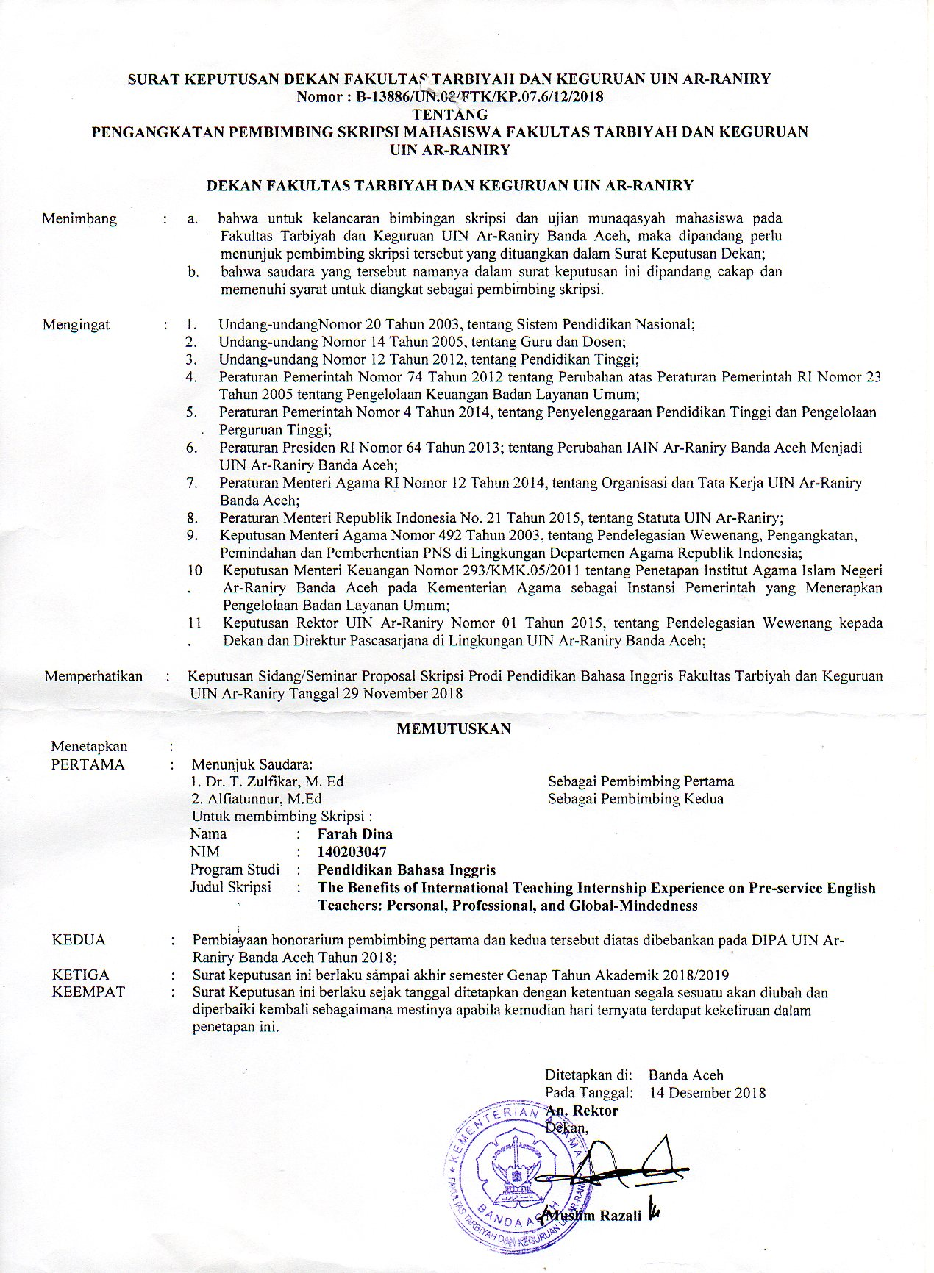

**Appendix B : Interview Instrument**

1. Does international teaching internship affect you as a person? If so, in what circumstances?
2. Tell me how you adapted in your host classroom in the school environment and in the class during the international teaching internship!
3. How were your relationships with your mentor in the school during the international internship? What did you learn from them?
4. What sort of teaching strategies, educational system or program did you find during the international teaching internship? How do you compare with Indonesia?
5. Has the experience impacted on your career goals or the type of schools you are willing to work in the future?
6. How did it feel to be in the environment where all people were different from you? How did you cope with it?
7. Has your trip experience changed your global awareness? How?

(Modified from Stanley, 2010)

**Appendix C : Explanatory Consent**

**Explanatory Consent**

February, 2019

Dear alumna of Sea Teacher program,

I am Farah Dina from UIN Ar-Raniry Banda Aceh. I am conducting a research entitled ‘The Benefits of International Teaching Internship Experience on Pre-Service English Teachers: Personal, Professional and Global Mindedness.” The objective of this study is explore the benefits of international teaching internship on personal, proffesional life and global-mindedness development of pre-service English teachers.

As you have participated in international teaching internship, I ask permission from you to participate in in-depth interview as my research participants. All of information will be handled with care, secret and professional. All names and information about your other identity will not be included in result discussion.

If you are willing to participate, please sign in this consent form.

I really appreciate your help in this research. If you have any question, feel free to contact me: +6285370300202 or E-mail: farah.dienaa@gmail.com .

Thank you very much.

Best Regards,

  
Farah Dina

Student of UIN Ar-Raniry

**Appendix D : Consent Forms**

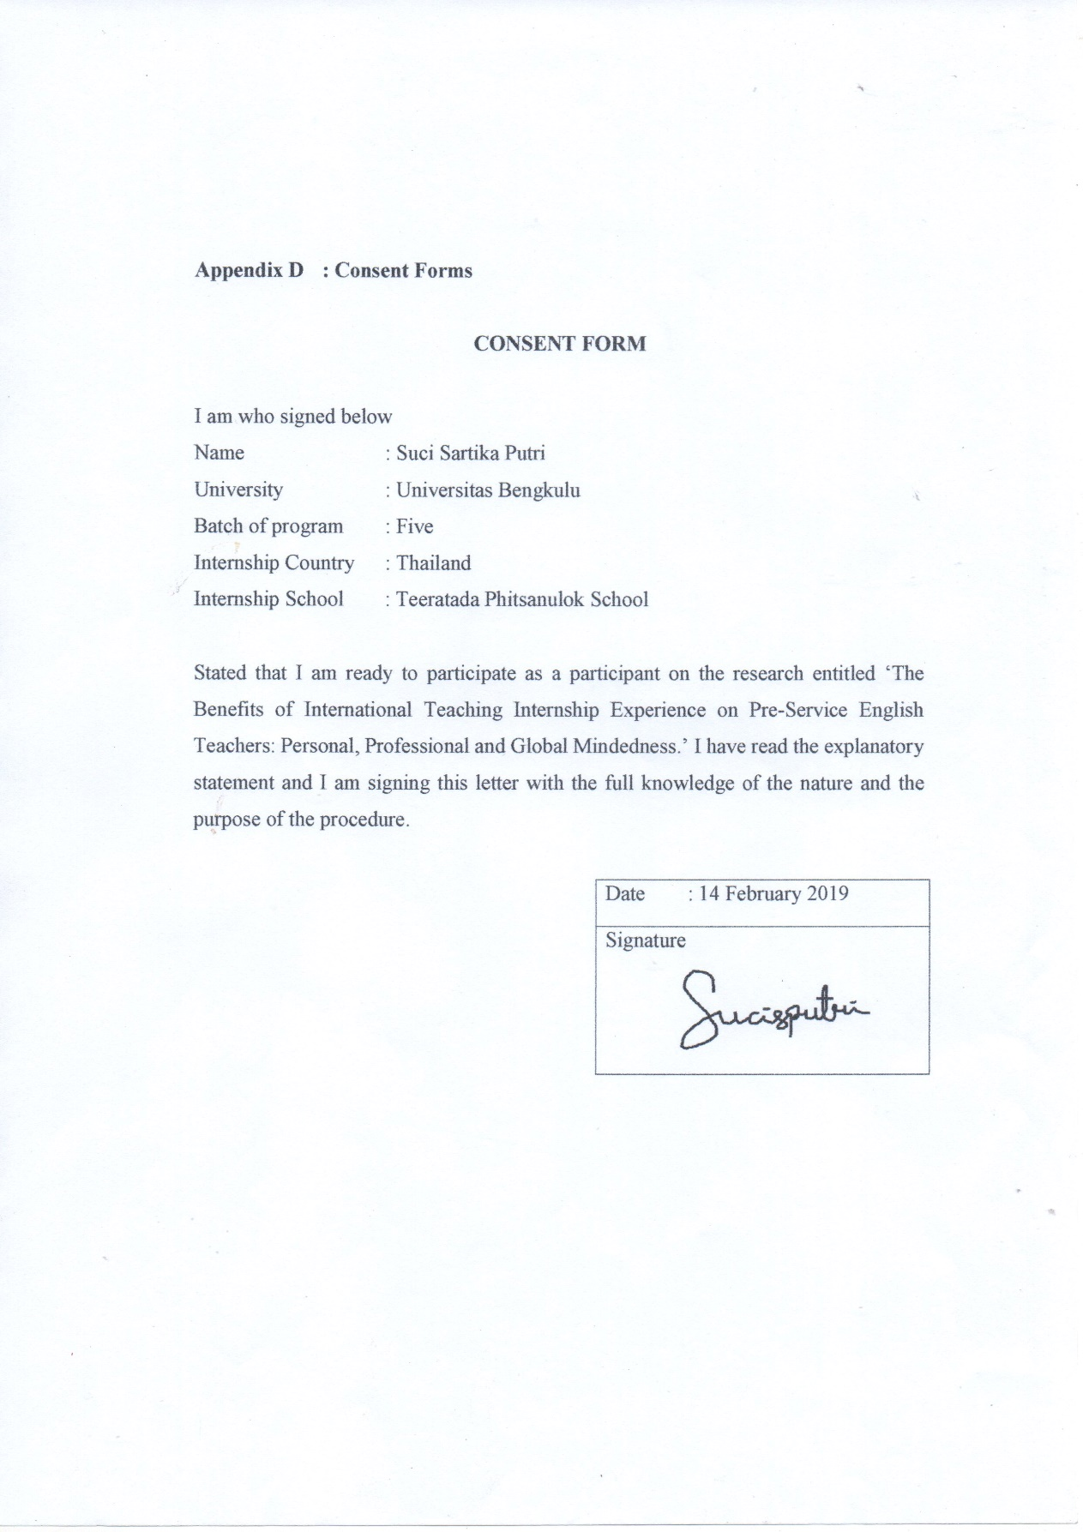

**CONSENT FORM**

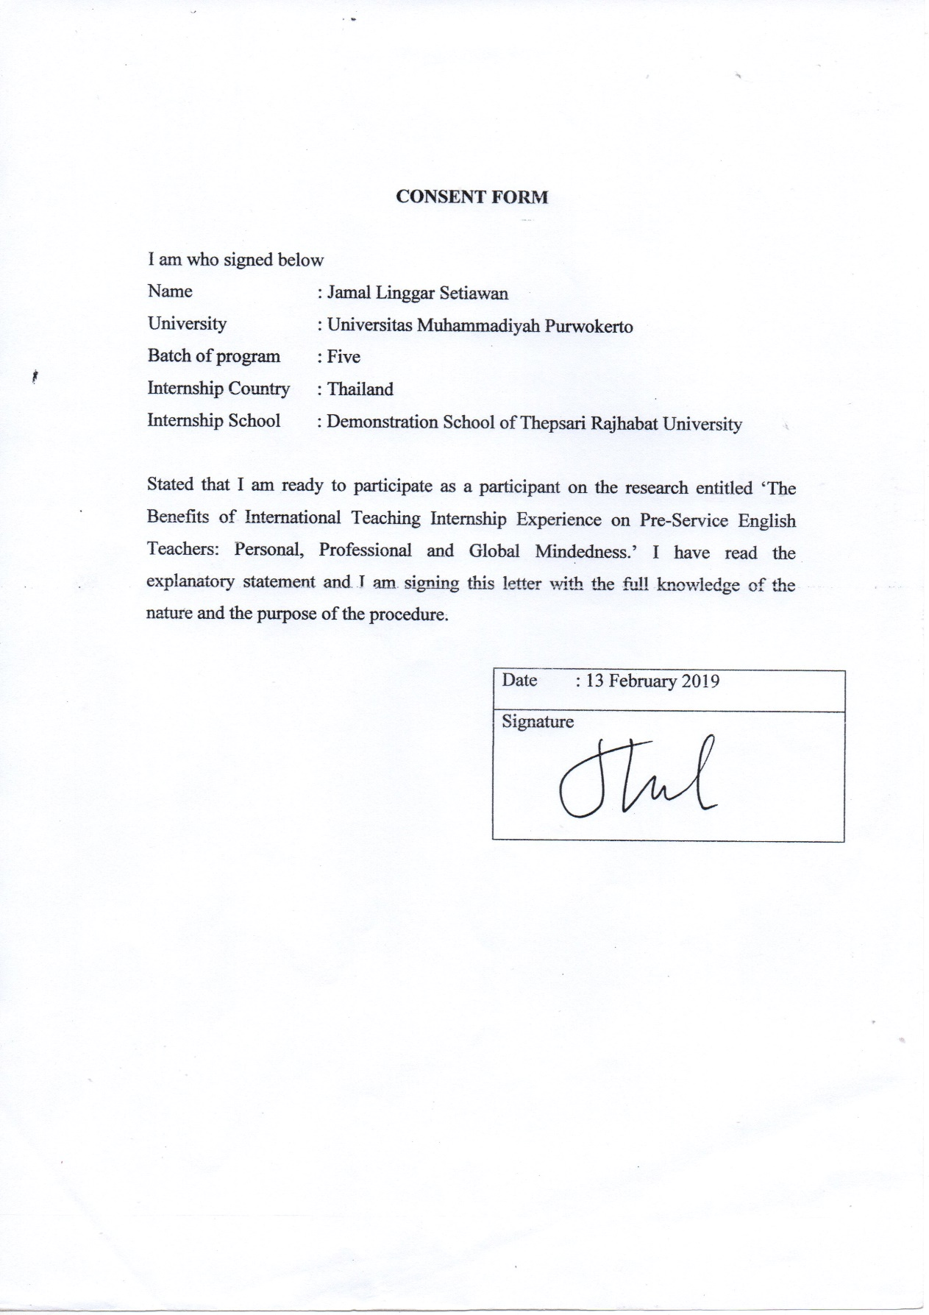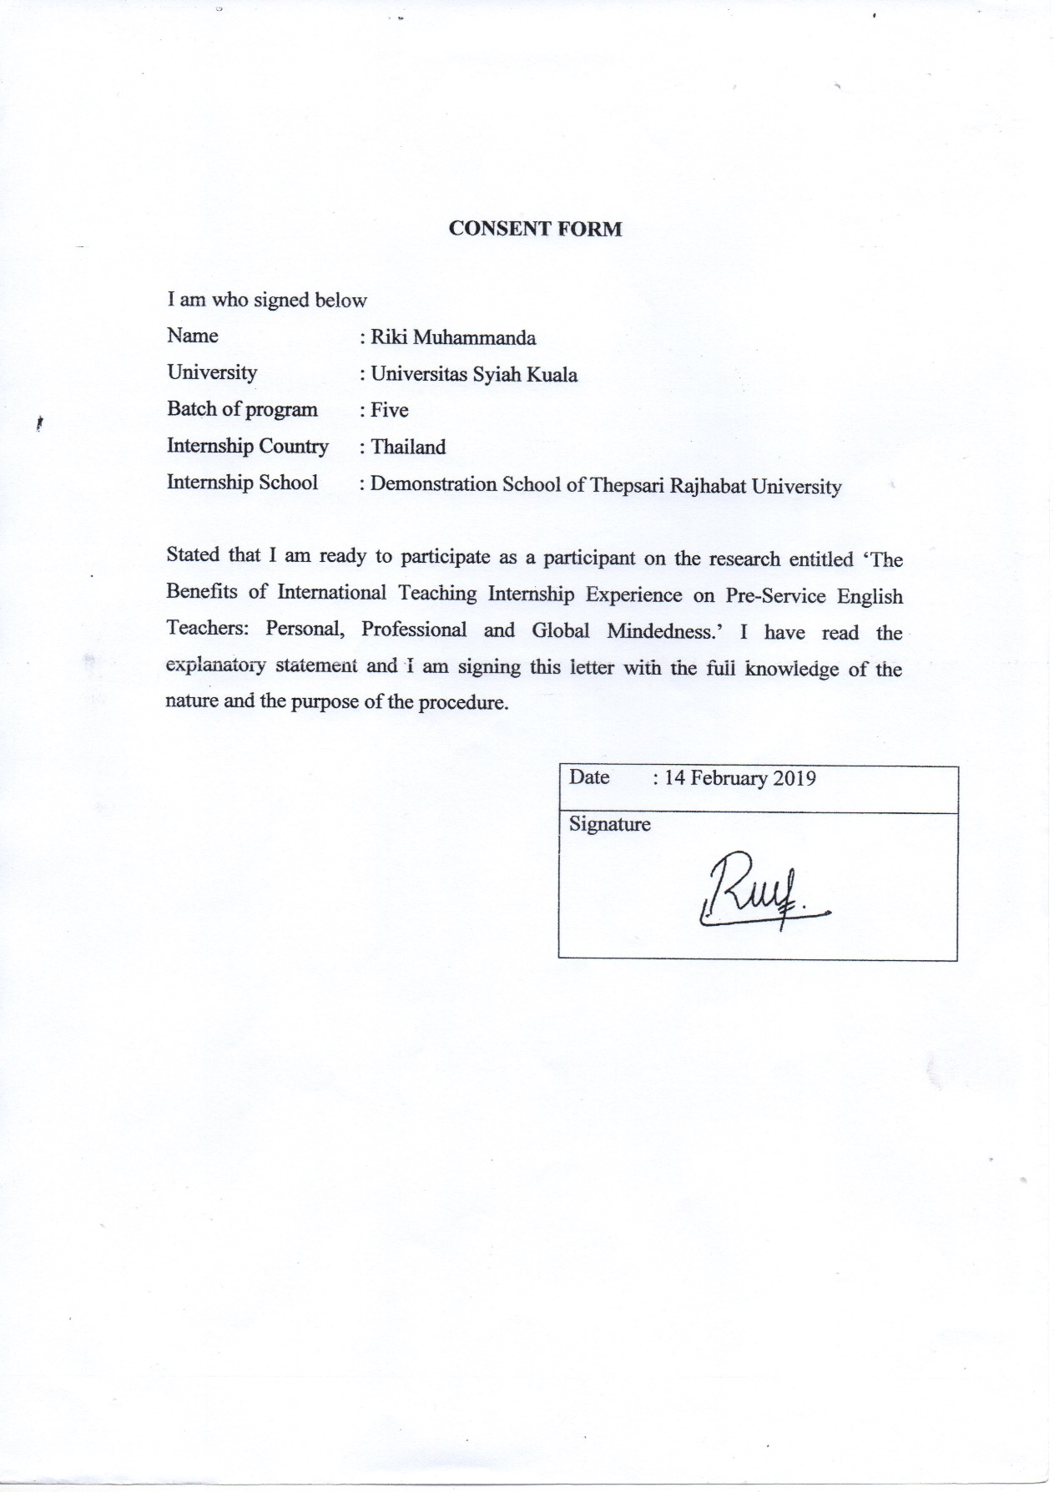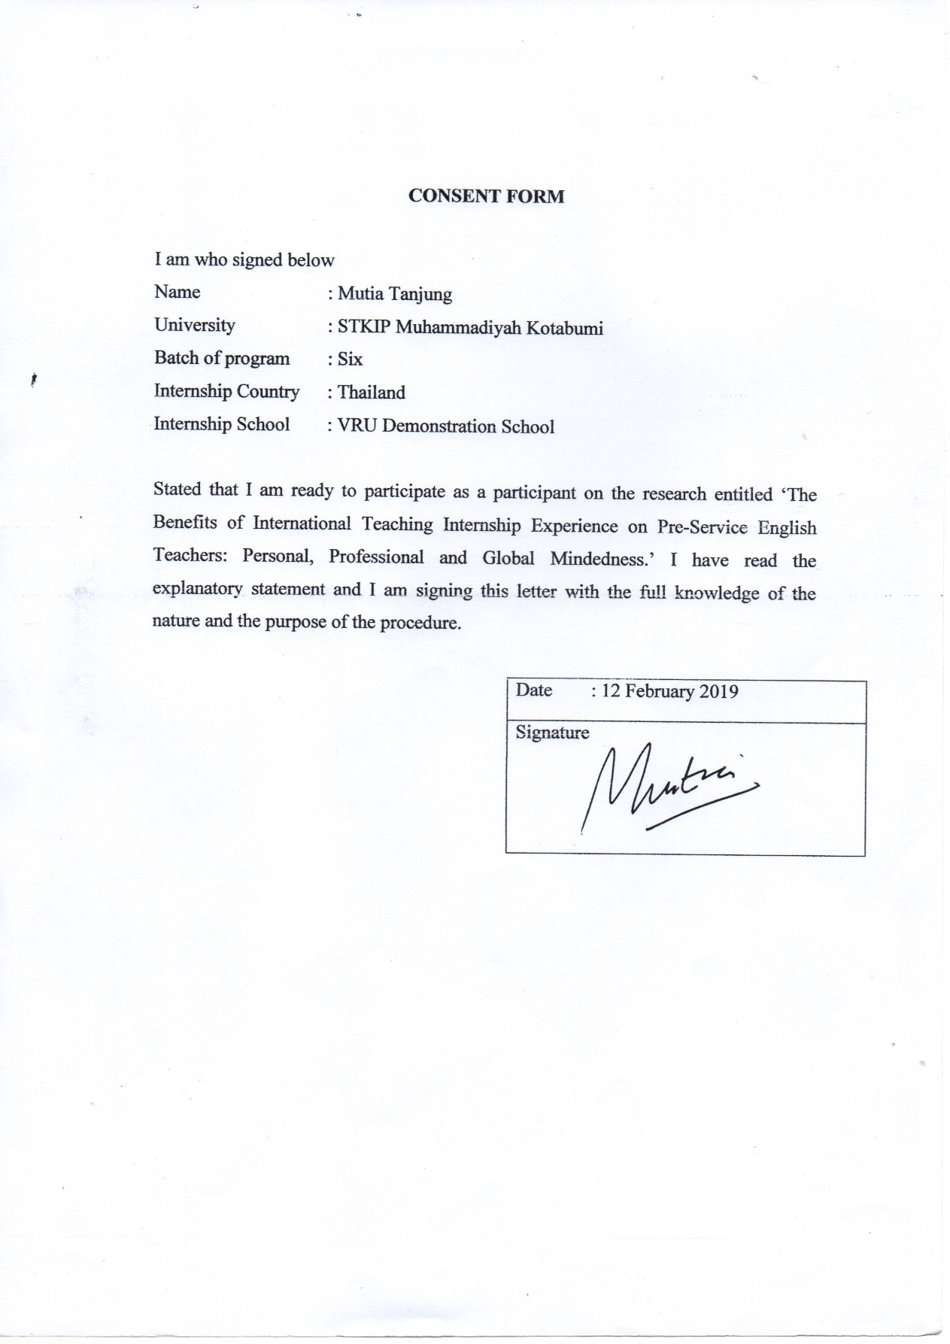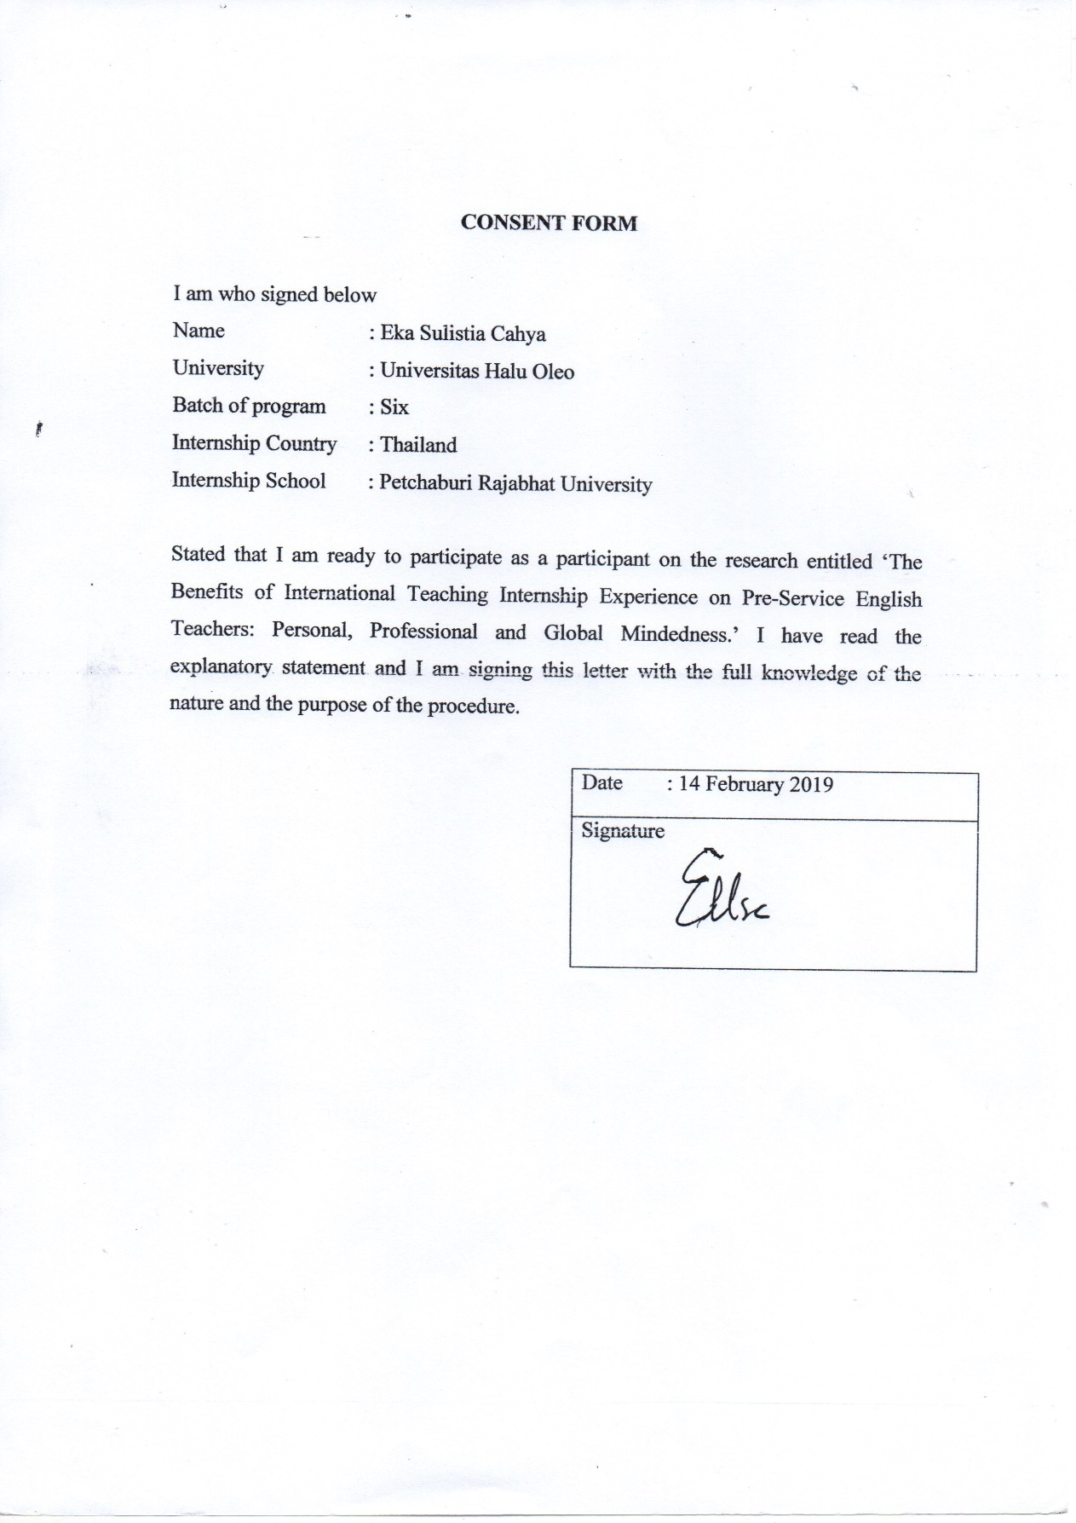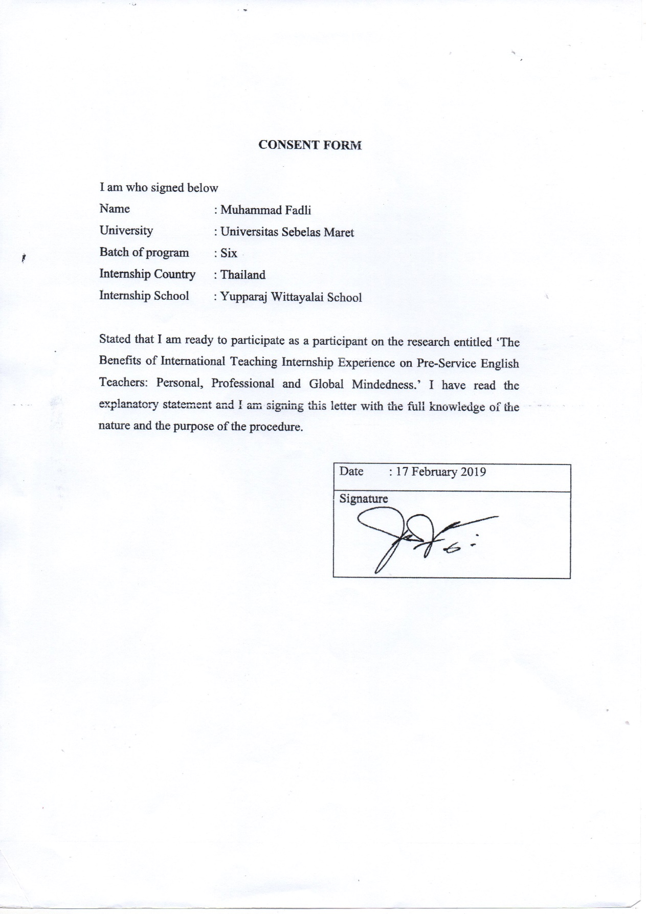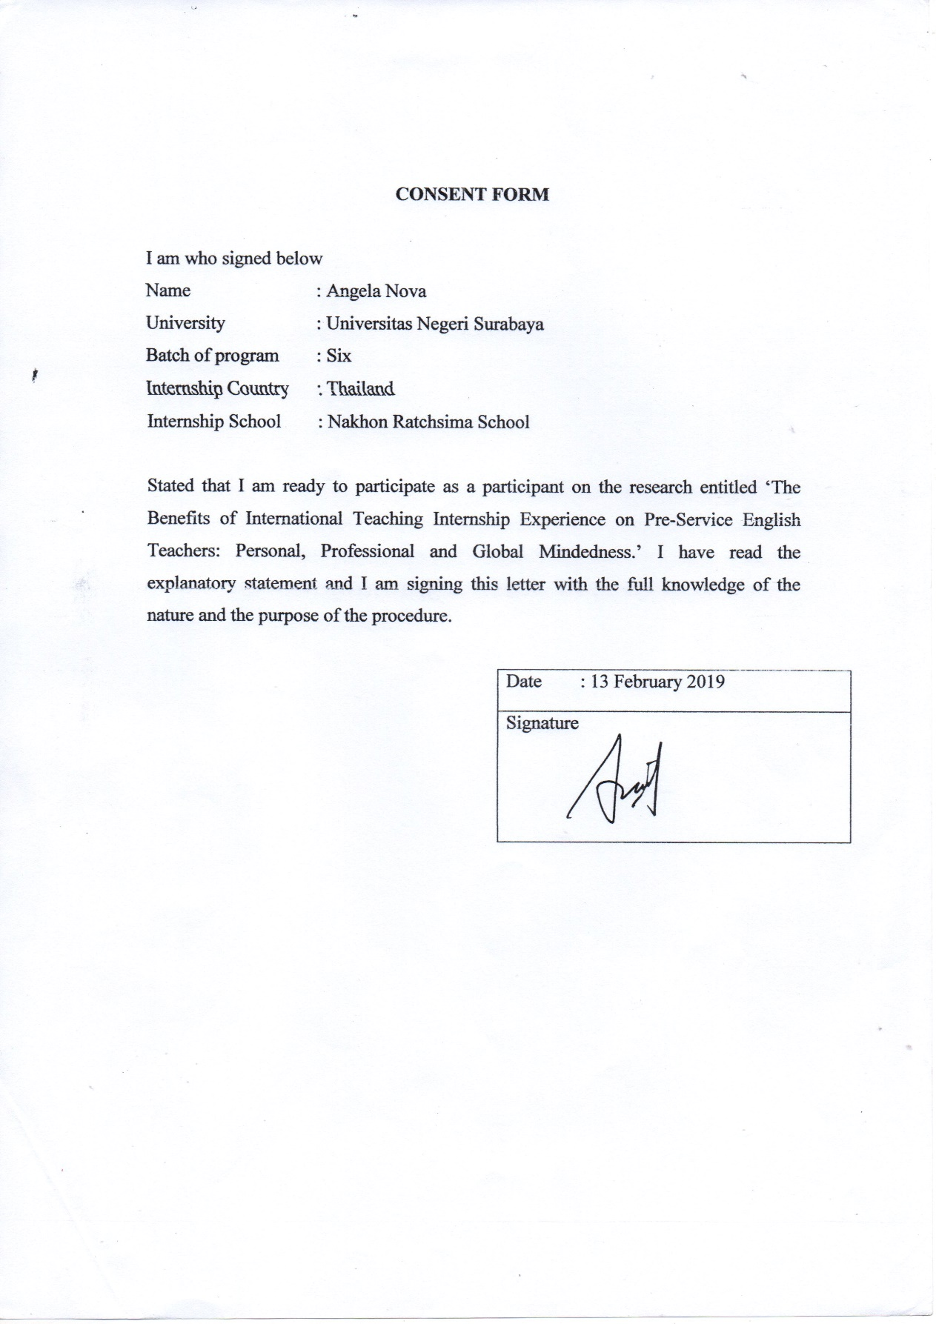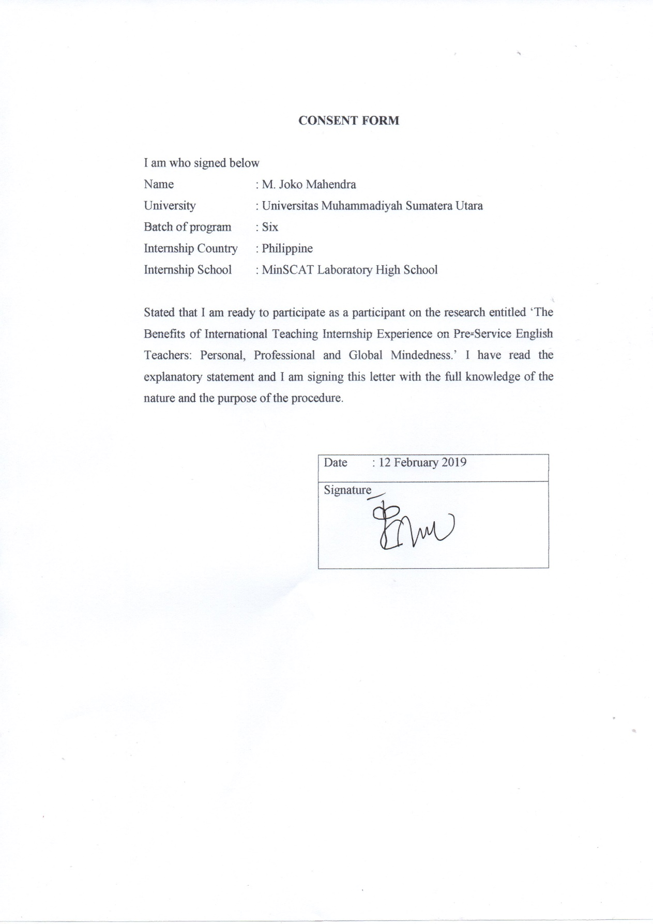

**AUTOBIOGRAPHY**

1. Name : Farah Dina
2. Place/ Date of Birth : Banda Aceh, 5th January 1997
3. Gender : Female
4. Religion : Islam
5. Nationality : Indonesian/Acehnese
6. Address : Tungkop, Darussalam, Aceh Besar
7. Marital Status : Single
8. Occupation/NIM : Student/140203047
9. The Parent
10. Father’s Name : Tarmizi Dahmy
11. Mother’s Name : Maryana
12. Occupation : Civil Servant
13. Address : Tungkop, Darussalam, Aceh Besar
14. Siblings
15. Brother : Zahrul Fuadi

Fadhli Ramadhan

1. Sister : Ulfa Fajrina

Nelis Sa’adah

1. Educational Background
2. Education Background
   1. Elementary School : MIN Tungkop (2002-2008)
   2. Junior High School : MTsN Tungkop (2008-2011)
   3. Senior High School : MAN Banda Aceh 1 (2011-2014)
   4. University : UIN Ar-Raniry (2014-2019)

Banda Aceh, March 31 2019

Farah Dina