**INVESTIGATING CHALLENGES OF EFL STUDENTS IN TEACHING PRACTICUM CLASS**

**THESIS**

Submitted by

**FATHUN MUBIN AGUSNI**

**NIM. 190203119**

Student of *Fakultas Tarbiyah dan Keguruan*

Department of English Language Education



**FAKULTAS TARBIYAH DAN KEGURUAN**

**UNIVERSITAS ISLAM NEGERI AR-RANIRY** **BANDA ACEH**

**2023 M / 1445 H**

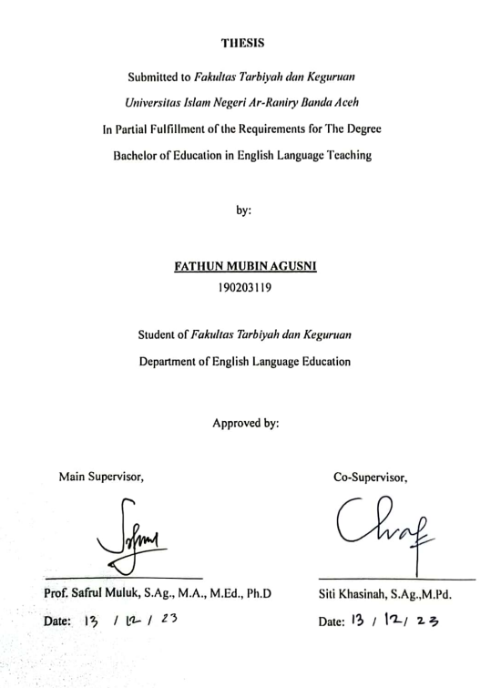

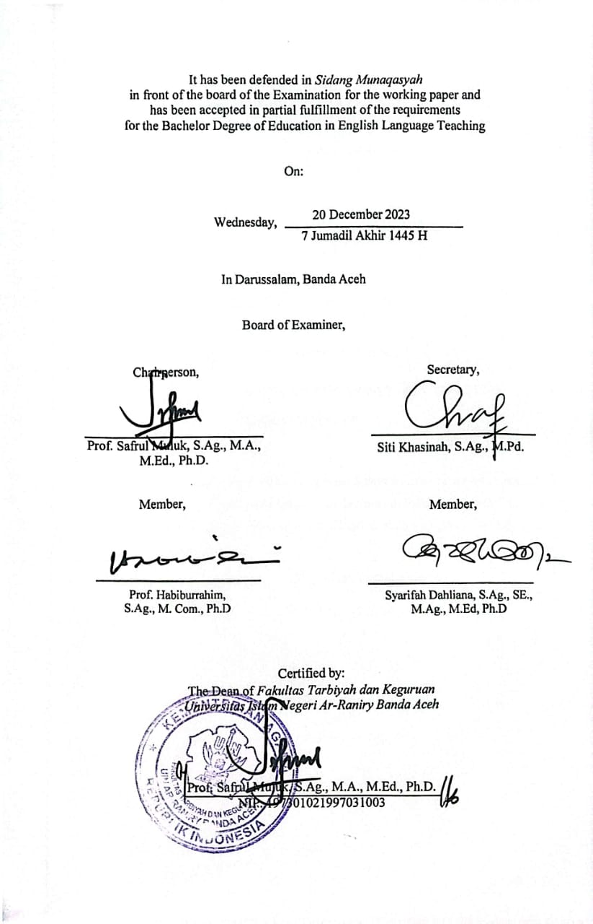

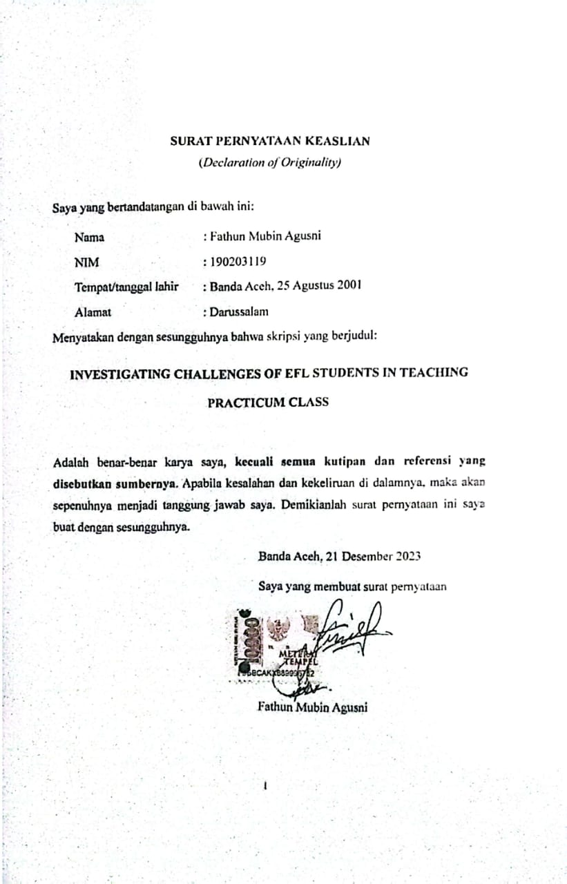**SURAT PERNYATAAN KEASLIAN**

(*Declaration of Originality)*

Saya yang bertandatangan di bawah ini:

Nama : Fathun Mubin Agusni

NIM : 190203119

Tempat/tanggal lahir : Banda Aceh, 25 Agustus 2001

Alamat : Darussalam

Menyatakan dengan sesungguhnya bahwa skripsi yang berjudul:

**INVESTIGATING CHALLENGES OF EFL STUDENTS IN TEACHING PRACTICUM CLASS**

Adalah benar-benar karya saya, **kecuali semua kutipan dan referensi yang disebutkan sumbernya**. Apabila kesalahan dan kekeliruan di dalamnya, maka akan sepenuhnya menjadi tanggung jawab saya. Demikianlah surat pernyataan ini saya buat dengan sesungguhnya.

Banda Aceh, 21 Desember 2023

Saya yang membuat surat pernyataan

Fathun Mubin Agusni

# DECLARATION OF ORIGINALITY

# ACKNOWLEDGEMENT



Alhamdulillah, I would like to express my deepest praises and thanks to Allah *Subhanahu wa Ta’ala*, who has blessed and given me chance, inspiration, and power to finish this thesis. Peace and salutation are being upon to our beloved Prophet Muhammad *Shallallahu Alaihi wa Sallam,* who has shown us the perfect example of the greatest human being.

Primarily to the many challenges encountered throughout the writing process, the researcher came to the conclusion that the thesis has several errors and weaknesses. to attain perfection. The author need advice and corrections. The author would like to express sincere thanks to everyone who helped with the following writing, spirit, suggestions, and advice as follows:

1. My sincere gratitude and regards go out to my parents, Agusni Yahya and Nurmawati, who are the two most significant individuals in my life and who never cease to pray for me, not forgetting my brother Fathun Qarib Agusni for always supporting, entertaining and coloring my life.
2. My main supervisor, Prof. Safrul Muluk, S.Ag., M.A., M.Ed., Ph.D., and my co-supervisor, Siti Khasinah, S.Ag., M.Pd., provided me with essential support, direction, encouragement, ideas, inspiration, and supervision. Syarifah Dahliana, S.Ag., SE., M.Ag., M.Ed, Ph.D as head of study program and Azizah, M.Pd as deputy head of study program who work hard to maintain the accreditation of the study program. In addition, I want to express my gratitude to all of the lecturers that I earned instruction from throughout my time studying at the State Islamic University of Ar-Raniry's English Language Education Department. May Allah bless them with peace and enjoyment in this life as well as beyond.
3. I am grateful to all of my high school friends who have supported me throughout the time I have worked on my thesis, particularly the members of "Boycreh" and "JNE Lovers" who are too many to list properly, i hope that we can all become as we had imagined.
4. Happy to be surrounded by friends in arms from batch 19 PBI who always give new sensations every time, especially the boys because the close solidarity makes me feel not secluded.
5. Thanks also to friends who have helped me provide input during the making of the thesis, to Nadaa Fatin, S.Pd who helped me from the beginning to the end of the thesis.
6. I would like to thank the EDSA organization for providing many experiences and relationships. Especially to all DPH, Ministers and Vice-ministers, and EDSA 2022/2023 members who helped me during my term as president.
7. My sincere gratitude goes out to the PBI Ar-Raniry students, particularly the responses who have been a huge help with this project.

I acknowledge that there are many errors in my thesis. As a result, any insightful criticism and recommendations are welcome and much valued.



Banda Aceh, 15 December 2023

Fathun Mubin Agusni

# ABSTRACT

Name : Fathun Mubin Agusni

Reg. No. : 190203119

Faculty : Tarbiyah dan Keguruan

Major : Department of English Language Education

Thesis’s Title : INVESTIGATING CHALLENGES OF EFL STUDENTS IN TEACHING PRACTICUM CLASS

Main Supervisor : Prof. Safrul Muluk, S.Ag., M.A., M.Ed., Ph.D

Co-Supervisor : Siti Khasinah, S.Ag., M.Pd

Keywords : Teaching Practicum, Micro Teaching, Student's Challenges.

One of the many developmental phases required to become a successful teacher is to enroll in teaching practicum courses. The aim of this study is to (1) determine the challenges that students face while implementing their practicum courses, (2) determine the factors that contribute to these problems. Purposive sampling and quantitative research methods, including the quantitative data collecting using questionnaires, were used in this study. The research's respondents were 23 students who were enrolled in the English Education Study Program at Ar-Raniry State Islamic University for the 2019 academic year. The results of this research indicate that (1) most students felt that the expense of the materials and the psychological element of the student were the most frequent obstacles they faced, as shown by their 44.67 questionnaire score (2). The variables that contribute to the difficulty of the teaching practicum class include a lack of teaching experience, the state of the classroom, and the average score of 66.80 from the questionnaire data.

# TABLE OF CONTENT

DECLARATION OF ORIGINALITY i

ACKNOWLEDGEMENT ii

ABSTRACT iv

TABLE OF CONTENT v

LIST OF TABELS vii

LIST OF DIAGRAM viii

LIST OF APPENDICES x

CHAPTER 1 1

INTRODUCTION 1

A. Background of study 1

B. Research Question 4

C. The Aim of this Study 4

D. Significance of this Study 5

E. Terminology 6

CHAPTER 2 8

A. Teaching Practicum Class 8

a. Definition 8

b. Stages of Teaching Practicum Class 9

c. Benefits of Teaching Practicum 13

d. Phase of Teaching Practicum 15

B. Student Challenges in Teaching Practicum 18

C. Relevance Studies 21

CHAPTER 3 24

RESEARCH METHOD 24

A. Research Methodology 24

B. Population and Sample 24

C. Technique In Collecting Data 25

D. Research Instrument 25

E. Technique Data Analysis 27

CHAPTER 4 30

FINDINGS AND DISCUSSION 30

A. Finding 30

B. Discussion 53

CHAPTER 5 55

A. Conclusion 55

B. Suggestion 56

REFERENCES 58

**APPENDICES**

**AUTOBIOGRAPHY**

# LIST OF TABELS

Table 3. 1 *List of Questionnaire by Muthmainnah* 27

Table 4. 1 Challenges Encountered 31

Table 4. 2 Score of Challenges Encountered 42

Table 4. 3 Factor Lead 45

Table 4. 4 Score of Factor Lead 50

# LIST OF DIAGRAM

*Diagram 4. 1* Teaching practicum activity doesn't contribute much to my understanding of my teaching abilities or the practical aspects of my future teaching endeavors.

*Diagram 4. 2* Teaching practicum activities doesn't provide me with any valuable chances to apply teaching skills*.*

*Diagram 4. 3* Teaching practicum activities don't assist me in identifying my teaching strengths and weaknesses

*Diagram 4. 4* During the Teaching Practicum Activity process, I encountered obstacles in costs (material development).

*Diagram 4. 5* Teaching practicum activities don't contribute to learning how to organize my time*.*

*Diagram 4. 6* Instead of offering practical opportunities to teach a lesson, teaching practicum activities don't help predict classroom problems or enhance my lesson planning*.*

*Diagram 4. 7* Teaching practicum activities don't contribute to an increase in self-confidence in teaching

*Diagram 4. 8* Teaching practicum activities don't offer opportunities for meaningful teacher-student communication.

*Diagram 4. 9* Engaging in teaching practicum activities doesn't help me understand the right gestures between students and teachers.

*Diagram 4. 10* Teaching Practicum Activity didn't contribute to the development of appropriate question scores

*Diagram 4. 11* Teaching practicum activity doesn't assist me in assessing students' skills

*Diagram 4. 12* Teaching practicum activity doesn't provide techniques to understand the psychological aspects of students.

*Diagram 4. 13* I think Lack of Experience lead to lack of my understanding with student.

*Diagram 4. 14* I think my public speaking skill is not good enough for teaching practicum class.

*Diagram 4. 15* The material I prepared for teaching practicum was difficult to apply.

*Diagram 4. 16* The classroom conditions in the Teaching Practicum activity do not fully match the original classroom conditions in the school.

*Diagram 4. 17* Its hard to teach because insufficient classroom facilities to support material development*.*

# LIST OF APPENDICES

Appendix A *Appointment Letter of Supervisor* 62

Appendix B *Questionnaire Guideline* 63

Appendix C *List of Questionnaire* 65

Appendix D *Form of Questionnaire.* 67

Appendix E *Result of Questionnaire.* 67

Appendix F *Responses of Participant* 73

# CHAPTER 1

## INTRODUCTION

This chapter is made to introduce the important points that will be explained, including the background of the study, research questions, objectives of the study, significance of the study, and terminology.

## A. **Background of study**

Knowledge is a bridge for humans to achieve success, it can come from non-verbal sources such as books or verbal. In the world of education, these two skills are trained to ensure that the next generation has qualified knowledge. One way to improve teaching skills is to take teaching practicum classes. Since 1960s, Teaching practicum class has been used as method for teaching and learning environment to improve teaching experience of future teachers.

The practice of self- can be achieved in a variety of ways, the two most prevalent of which are shadowing an experienced educator and learning by doing in one's own classroom. However, each of them has their own set of negative qualities. On the other hand, microteaching is beneficial in that it helps to eliminate errors and promotes stronger teaching skills for both beginning and experienced teachers. The benefits of participating in microteaching include an increase in self-confidence, an improvement in actual teaching performances, and the development of abilities related to classroom management. (Remesh, 2013.)

In conclusion, teaching practicum class provides a controlled and supportive environment for skill development, targeted feedback, time efficiency, adaptability, enhanced confidence, and possibilities for cooperation. These are just few of the many benefits that teaching practicum class brings to the table for instructors. It is an efficient approach that can improve teaching techniques and bring about an overall improvement in the quality of education. In accommodating aspiring teachers with valuable opportunities to develop effective teaching strategies, teaching practicum class is a remarkable technology in teaching educating programs (Koross, 2016).

Teaching practicum or Teaching practicum class at PBI is an advanced internship course from ECD (English Course Design) in semester 4, student learn how to make lesson plans in class, which will then be used in Teaching practicum class classes. Lecturers who teach this course are also people who understand teaching practicum class well and take part in teaching practicum class workshop held at PBI every year.

Teaching practicum class is organized under normal situations, and it could be a very complex classroom environment by simplifying student numbers, class times, content, and focus on specific behavioral situations that participants can handle.

A technique for education known as microteaching is giving lessons to a restricted number of students on a modest scale, often inside of a supervised setting and for a constrained amount of time. The primary goal is to equip future educators or trainers with hands-on experience in the classroom and in engaging with students.

This will be the primary focal point. Contributes to the growth of teaching skills and knowledge of effective instructional strategies. In a regulated environment, teacher candidates can practice teaching in authentic settings and receive immediate feedback from either observers or their fellow teacher candidates.

Typically, each microteaching session lasts between 10 and 20 minutes. Due to the brief duration, candidates for teaching positions are able to focus on specific learning objectives and refine their teaching skills in a condensed period of time.

Focus on developing essential teaching skills, such as effectively preparing classes, presenting information plainly, forming strong connections with students, and determining their level of comprehension. Immediate feedback following the conclusion of the course.

Observers or other applicants for the same teaching position provide prospective instructors with constructive evaluations that highlight both their strengths and areas for development in the classroom. After completing the microteaching session, prospective instructors are given the opportunity to ruminate on their teaching experience.

It has been shown that microteaching is effective for teacher training because it provides actual experience and fast feedback, which improves teaching skills.

Even though the application of teaching practicum class should be carried out optimally and effectively, there are still some internal weaknesses such as time-consuming, feedback quality, lack of real students, etc. There are still students who experience difficulties in learning teaching practicum class properly. There were several obstacles, such as the lack of materials provided by students in teaching practicum classes such as lesson plans, materials, etc. And students who do not fully understand the implementation of lesson plans which will cost more time in the classroom to learn lesson plan.

Can (2009) stated that appropriate methods should be administered so that student teachers are actively involved in real teaching-learning processes, learn to cope with real classroom problems, can access a variety of instructional resources, and can use the time effectively.

## B. **Research Question**

The researcher formulated the research questions of this study after explaining the background are:

1. What challenges do EFL students encounter during teaching practicum classes?
2. What factors lead to those difficulties in teaching practicum class?

## C. The Aim of this Study

The purpose of this study is to investigate and find out the difficulties of EFL students in teaching practicum classes, and the factors from these problems.

## D. Significance of this Study

All process of observation, writing, and study should be having clear and significance of study, the researcher hopes that this study will hopefully be beneficial to the followings:

1. The Researchers

This research hopefully will fulfill previous research and serve new lessons and experiences that useful for encourage other research about teaching practicum. For novice researchers who have the same topic, it is hoped that this study can be used as material for finding credible and reliable information in the future.

2. Lecturers

This research sheds light on what are the point of view regarding difficulties in class from students in teaching practicum classes, and hopefully this can be used as a quality improvement in the future for lecturers.

3. Students

This research can make students more expressive in expressing the difficulties they experience in teaching practicum classes.

4. Reader

This research is expected to be able to contribute to readers and can be a reference, especially for all students of PBI UIN Banda Aceh in the context of teaching practicum class insights, ideas and references in the future.

## E. Terminology

To make this study intelligible, author must describe numerous things, including:

1. Teaching Practicum Class

The teaching practicum class at UIN Tarbiyah is called micro teaching, which is meant to simulate a classroom environment, can help students build the professional abilities required for teachers in any sort of educational institution. This course provides students with the opportunity to self-evaluate what works and what does not in terms of their teaching skills competence. (Muluk, Habiburrahim, & Ardiansyah, 2020)

Teaching practicum class at PBI UIN Ar-Raniry is a 6th semester course with 3 credits. Students must complete a micro teaching course as one of their mandatory topics before graduating from the Faculty of Education and Teacher Training (FTK) of UIN, where the research took place.

2. Challenges

The phrase "Challenges" refers to issues, or impediments that individuals or organizations face when attempting to accomplish specified goals or tasks. Challenges in education can arise from a variety of facets of the teaching and learning process.

Okobia, Augustine, & Osagie (2013) stated that the problems in teaching practicum class such as difficulty in managing students with different skills, the time allotment for teaching practice is short, lack of instructional materials and resources, and others.

This inclusive goal of education may be accomplished by well-coordinated efforts on the part of all parties engaged in the teaching and learning process, including students, instructors, facilities, and other resources, among other things. (Munzaki, 2016)

# CHAPTER 2

**LITERATURE REVIEW**

This chapter is presented to relate content and context to the title of the study. There are several related problems that can help make this study.

A. Teaching Practicum Class

### a. Definition

Teaching practicum class is an educational strategy that involves breaking down a lesson into smaller, more manageable components. This provides instructors with the opportunity to practice and enhance their teaching skills in a setting that is both regulated and supportive. Because of its myriad advantages, the methodology of micro teaching has gained widespread acceptance as a practice that is advantageous for both inexperienced and seasoned educators. The same as the existing courses at UIN Ar-Raniry, namely Micro Teaching classes with a total of 3 credits, in semester 6 in 2022 and changed in 2023 to courses in semester 7.

Based on Helmiati (2013) Micro teaching derives from the words micro, which stands for brief and restricted, and teaching, which stands for education. Micro education takes a distinct linguistic turn while maintaining the same content. Sahardin, (2020) stated that in order to prepare student teachers to become instructors, teaching practicum class occurs.

A teacher is a qualified educator entrusted with the responsibility of instructing, training, directing, supervising, assessing, and evaluating his or her pupils. Conceptually, micro teaching is a teaching approach that puts an emphasis on the creation of media for both instructors and students in the classroom setting.

### b. Stages of Teaching Practicum Class

Teaching practicum class frequently takes place in collaborative learning contexts, where teachers are able to observe and learn from one another's classroom experiences. This type of shared learning is an essential component of teaching practicum class. Peer feedback and conversation lead to a richer interchange of ideas, best practices, and novel ways of approaching the teaching profession. This collaborative feature helps to foster a community of educators who are supportive of one another.

Zaki (2014) mentioned that practice systems in controlled environment in purpose of increasing concentration on specified teaching behaviour and practice teaching under controlled conditions defines teaching practicum class. Zaki (2014) also elaborate stages of teaching practicum class:

#### Plan

At this planning stage, teaching objectives are determined related to the behavior of the pre service teacher as desired. In order to make the objectives effective, some way of teaching activities has been analyzed into various types such as questioning, demonstransting, explaining, etc), and the related behaviors of teacher during applying the teaching activities can be scaled down into more focus of training (Dwight & Arthur, 1968).

Abdurrahman (2010) stated that the ability to construct lesson plans, select teaching objectives, speak in front of a group, ask questions, and employ assessment procedures are all abilities that are developed through teaching practicum class. In a cozy setting, teachers' self-confidence increases. It gives you the chance to quickly pick up a variety of skills that are crucial for teaching.

The teaching steps of teaching practicum class can be listed as follows:

1. Create a 5- 15 Minute lesson plan on a specific topic.
2. Video recording of lessons (where possible).
3. View recorded lessons on video.
4. Evaluation of lessons by both teacher and audience.
5. Prepare and re-present lessons.
6. Re-evaluation (İlhan,2009).

Planning a model lesson is a good way to get experience in achieving teaching objectives. It demonstrates the value of planning, structuring, and presenting in helping students learn. Choosing activities, organizing them logically, and sustaining improvement allow one to integrate the activities with the curriculum as a whole. Being given rapid feedback is a way to gauge productivity and employ training techniques. A strong learning atmosphere may be created by asking pertinent questions.

#### Teach

During this stage, the pre-service teacher deliver their lesson plans to a select set of students during the teaching phase. There are somes styles of teaching practicum class styles that can be delivered to students, such as:

#### Mini lessons

The most common type of microteaching is mini-lessons. It is giving a succinct, concentrated lecture on a particular subject or skill to a small group of students—or even just one student. By using this strategy, you may improve your presenting abilities and gauge how effectively the student(s) absorbed the subject matter. You can also get opinions on the lesson from each individual student and the class supervisor (if there is one).

#### One-minute lessons

This approach delivers a lesson in exactly 60 seconds, as the name suggests. Typically, one-minute lectures are intended to instruct teacher on how to prepare and present a valuable lesson in a fast-paced, high-pressure setting.

To employ this technique, choose a portion of a certain subject that pre-service teacher can effectively describe. This can be done by outlining a fresh idea or showing a specific method. The next step is to gather the tools pre-service teacher need to communicate in a straightforward way, such as diagrams, pictures, charts, and graphs. (Storm, 2023)

#### Role-playing

When students participate actively in learning, such as through playing out a play, they may be better able to comprehend specific concepts or abilities. Try having learners take on various roles that are essential to the lesson if pre-service teachers trying to convey a concept like this to them.

Pre-service teacher may communicate with students and hone material delivering techniques in this way. Additionally, because they are actively participating in the class rather than only listening, it helps students digest knowledge more effectively.

#### Case studies

This technique for microteaching entails using hypothetical or actual case studies to impart a lesson. Hembram (2021) add that to provide instructors the chance to demonstrate their ability to adapt hypothetical and theoretical concepts and ideas to real-life circumstances, it is frequently utilized in teacher training and development programs.

By using this technique, it is necessary to involve students in evaluating case studies and exploring various kinds of problem solving strategies. Case studies can also be used to explore key ideas and theories.

#### Video recording

This teaching style can be used if there are no students present or the teacher is teaching online learners. Recorded video can also be one way to teach, by recording a pre-service teacher teaching in an empty classroom. (Storm, 2023)

After finishing teaching, the lecturers may watch the recording and give feedback on how the pre-service teacher presented the topic, the pace, the tone of voice, and the body language used in the classroom. By taking these steps, pre-service teachers may improve their delivery and presentation abilities as well as create succinct and informative instructional materials. (Pham, 2017)

This method is used when I take my microteaching class; we shoot ourselves in the classroom, and others act like students by giving questions and opinions to improve teaching skills. The lecturer also gave some additional input to the pre-service teacher who performed. By incorporating video recording into pre-service education, students may examine, reflect on, evaluate, and improve their didactic abilities. This allows for self-report, self-assessment, and self-reflection.

### c. Benefits of Teaching Practicum

The benefits of teaching practicum can be broken down into several important categories, the opportunity to develop and improve one's teaching abilities is presented to teachers in the form of teaching practicum class, which affords them this possibility. Teachers are able to discover areas in which they could enhance their education by concentrating on specific teaching components, such as classroom management, questioning tactics, or instructional strategies. This allows teachers to experiment with multiple approaches.

Teaching practicum class provides teachers with the opportunity to hone their abilities in a setting that is both safe and managed, freeing them from the stress that comes with working in a traditional classroom setting. It gives them the opportunity to learn from their errors, accept useful criticism, and think critically about the ways in which they educate, all of which contribute to ongoing development and progress.

Feedback that is specific and delivered in a timely manner is one of the most significant benefits that can be derived by implementing microteaching strategies. Observers, which can include peers, mentors, or supervisors, have the ability to provide constructive feedback on particular portions of the class. This feedback assists teachers in identifying their strengths as well as areas in which they could use development. This feedback loop encourages introspective behavior and contributes to professional growth.

Efficiency in use of time Teaching practicum class, which focuses on certain teaching abilities or pieces of a lesson, enables efficient use of time since it narrows the scope of the teaching endeavor. The ability of teachers to engage in several teaching practicum class sessions within a restricted amount of time paves the way for rigorous practice and the development of skills that are specifically targeted.

Teaching practicum class is a flexible strategy that can be modified to numerous teaching circumstances and subjects. This adaptability makes it a desirable method. It can be applied to the training of teachers in a variety of subject areas, from language arts to mathematics, as well as in a variety of educational settings, such as elementary schools or universities. Because of its malleability, teaching practicum class is a versatile instrument that may be used for both the education and professional development of teachers.

The more experience teachers have and the more feedback they get on their lessons in a safe setting, the more self-assured they become about their ability as educators. They are able to improve their methods, try out a variety of teaching approaches, and develop a toolbox full of productive instructional procedures by engaging in microteaching. This enhanced confidence has a good impact on the students' overall performance in the classroom.

### d. Phase of Teaching Practicum

The teaching practicum phase obtain teachers will have the opportunity to analyze, experiment, and reflect on their teaching methods, fostering a continuous process of professional growth and development.

1. Observe (critique)

During the observation phase, the instructor evaluates the pre-service teachers' performance and gives them comments. With barely any students and a very brief lesson or subject, microteaching can be practiced. The complexity of genuine instruction is made easier since after every practice session, quick feedback may be acquired. (Remesh, 2013)

When making observations it also requires high accuracy, such as in the video recording teaching style. Linman (1980) stated that preservice instructors were unable to act spontaneously when microteaching classes were filmed. However, it should also be taken into account that the video recording will compel pre-service instructors to behave positively when instructing and may favorably impact the growth of their self-efficacy in the classroom. A video record also makes it simpler for the instructor to evaluate the pre-service teachers' performances. Without a video recorder to capture pre-service teachers' performances, it may be difficult to recall both their positive and bad behaviors, leading to inaccurate and insufficient comments. One of the most crucial components of microteaching is feedback.

In any event, basing the evaluation on the pre-service teacher's real performance may result in more accurate findings than assessing pre-service teacher learning and competency based only on what was written on a piece of paper.

2. Re-plan

Each pre-service teacher creates an updated lesson plan for the same lesson or a different subject during the re-plan stage in order to employ their teaching techniques more effectively considering the implications of the instructor's comments and feedback. (Silalahi, 2020)

3. Re-teach

In the re-teach phase, a revised lesson is imparted to an unfamiliar but comparable class of students, the prepared plan is followed when making a presentation. A presenter and an observer who is a teaching candidate are involved in this phase. Both applicants actively engage in the learning process (Segall, 2011). While the presenter is presenting the presentation, the teacher candidates who are observing take notes. By holding these notes in their hands, the spectator can therefore gain a critical viewpoint. It is believed that teaching may also get better through observation in the classroom.

4. Re-observe

In comparison to conventional methods of evaluation, a microteaching clinic might offer a less intimidating environment for monitoring. A microteaching clinic is thought of as neutral ground because the focus is on the teacher's instructional support, despite the fact that most instructors are fairly sensitive about having supervisors monitor them in their classrooms. Regardless of the precise objectives of the microteaching lesson, both the instructor and the supervisor are aware of them beforehand. As a result, the criticism time that follows the microlesson enables the instructor and the supervisor to discuss development within the specific area of shared concern in a realistic manner. (Blomberg, 2011)

Micro-teaching is useful for developing and disseminating specific teaching abilities, eliminating errors, and assisting instructors in adjusting to new responsibilities and changes. It makes it possible to comprehend crucial classroom-teaching actions. It boosts the confidence of teaching applicants. It offers a broad application area for instructors in pre-service and in-the-field alike. It makes it possible to create instructional competency models. It entails quick response.

B. Student Challenges in Teaching Practicum

When it comes to conducting microteaching sessions, students might run into a number of common challenges. These challenges can be seen from the point of view of the students. The following are some of the challenges that students could encounter.

The major worries of teacher trainees during their teaching process stated by Noel (2007) were primarily about themselves, such as self-confidence, dedication, health, and personality. Also, they are having difficulty trusting in their own abilities to modify students attitudes towards learning and discipline. The trainees' lack of self-confidence was impacted by their own theoretical comprehend of the topic or subjects being taught.

In addition, Nugraheni (2019) stated that Anxiety on stage is something that a lot of students go through when they have to microteach in front of their fellow students and professors. This is because they feel that they fear of seeming foolish in front of the others.

Furthermore, Matafane (2020) stated that teacher must find and show interesting or entertaining material, because it is their responsibility to choose and provide material which is relevant and not repetitive according to their needs. But sometimes it is difficult to locate relevant material and convey it in a way that appeals to the audience.

Besides, managing track of time. It's possible that students may struggle to keep track of time when participating in microteaching sessions. They need to guarantee that they can finish all of the learning components that have been prepared within the time that has been allowed to them. (Meigawati, 2016)

Dealing with Student replies. In order to be successful in microteaching, students need to be able to provide suitable replies to both questions and other student responses. Because it may be difficult to manage the interactions in a classroom while still offering replies that are helpful. Noel (2007) also stated that students diverse abilities could cause problems too, because there are three types of learners according to David (2023) slow learners, reluctant learners and rapid learners.

Based on the explanation above, these are some common problems faced by students while undergoing teaching practicum classes, including feeling anxious in front of lecturers or fellow students, providing exciting and relevant material, managing time appropriately, and facing different student abilities.

Reacting to these problems, there are some solutions that can improve pre-service teacher teaching skills, such as had teaching experience way before take teaching practicum class course.

Adjusting to the role of the teacher Students who are not used to teaching may have trouble adjusting to the role of the instructor in a classroom setting. They need to become proficient in various teaching methods, be able to effectively manage courses, and engage in conversation with students.

Khasinah, Masna & Siregar (2020) stated that students who are uncomfortable teaching might utilize part-time employment as a learning opportunity to hone their skills, and it is advised that they find a part-time position that is associated with their course of study.

According to Nuzulia (2018), the reason for a teacher's success or failure while teaching is connected to the component of teaching skill that they felt, whether it has to be re-organized or not. Before entering the classroom and referring to their practises, pre-service English teachers should feel free to reflect on everything related to their teaching practises based on their perception, feelings, and beliefs (theory).

Even though the problems faced by pre-service teachers are very diverse, solutions are also available, such as having teaching experience before taking teaching practicum classes, practicing and finalizing teaching materials, and not feeling bound by classroom conditions that might be considered stressful.

C. Relevance Studies

Relevant studies are needed to compare previous research studies in order to find out insights and deficiencies in these studies, and are useful in current research. The first previous research was conducted by Rahma Nuzulia (2016) from department of English language education faculty of psychology and sociocultural sciences Islamic University of Indonesia Yogyakarta. This research entitled “Pre-Service Teachers’ Perception On The Reflective Teaching Practice In Micro-Teaching Subject of English Language Education Department of Universitas Islam Indonesia”. This research aims to know how the reflective teaching practice implemented in micro-teaching subject and to find out the students‟ perceptions of their experience in terms of the challenges, Challenges, and benefits of reflective teaching.

The result of this study shows that the The challenge of pre-service reflective teaching Teachers in the micro-teaching field find it challenging to reflect on offering peer evaluation, since emotional and feeling aspects interfere with their reflective teaching process. Most pre-service teachers can reflect some areas of teaching skill such as student characteristics, time management, educational materials plans, teaching material, nervous confidential, and problems with teacher ability such as mastery of subject skill and use of appropriate teaching method through reflective teaching strategy.

The second previous research was done by Awalia Rhaodatul Mutmainnah (2018) from English Education Study Program Faculty Of Teachers Training And Education Of Makassar Muhammadiyah university. This research entitled “Students’ Perception Towards Microteaching Subject By The English Education Study Program Of Makassar Muhammadiyah University”. The purpose of this research is to find Students' perceptions of the microteaching topic at Makassar Muhammadiyah University's English Education Study Programme, and if the Microteaching subject affects the English Education Study Programme at Makassar Muhammadiyah University. This study uses mixed method, interview and questionnaire.

The result of this study students had a pleasant experience after studying the microteaching topic, and it supports their teaching abilities before performing teaching practise in school and minimises mistakes while doing teaching practise in the future. The difference between this study and her study the instrument. Her study use interview and questionnaire, while this study utilize questionnaire.

The last previous research was conducted by Ardiansyah (2018) from Faculty of Education and Teacher Training Ar-Raniry State Islamic University Darussalam Banda Aceh. This research entitled “The correlation between Teaching practicum class Grade and Their Teaching Ability During Pre-service Teaching”. This study aims to investigate at the correlation between teaching practicum class scores and ability during pre-assignment teaching of English Language Education students at the UIN Ar-Raniry Faculty of Education and Teacher Training. The quantitative technique was applied in this research.

The result of this study indicates, student teaching skill influenced by teaching practicum class score, and thats the only factor that impact student teaching skill. The difference between this study and his research is Ardiansyah investigated the correlation between teaching practicum class scores and student teaching abilities, while this research is focused on the problems faced by students during teaching practicum class courses.

# CHAPTER 3

## RESEARCH METHOD

A. Research Methodology

Methodology in research is the procedure followed by researchers while conducting experiments or gathering data. It describes the overarching approach used to collect data, evaluate results, and make credible conclusions from the study. Researchers may use the approach as a guide for developing and testing hypotheses and completing the goals of their investigation.

Quantitative studies examine social issues by gathering and analyzing numerical data using statistical methods. The current research used a descriptive survey method. The researcher had a genuine interest in the challenges that students face during teaching practicum class sessions.

B. Population and Sample

A population, in the words of Creswell (2012), is a collection of individuals who share certain traits. Representative sample, also outlined by Creswell (2012), is a subset of the target population that is chosen for study in order to compile data on the target population. Arikunto (2010) did, however, add that when the population is more than 100, it would be better to include 10–25% or more of the population. If the population is smaller than 100, then all of them should be included in the research sample. Thus, the author selected 23 students out of 180 students for this study.

The population of this study is 2019 English Education students at UIN Ar-Raniry Banda Aceh with a total number of 180 students. By using purposive sampling, which is narrowing the population into samples that take micro teaching classes in 2022/2023. The number of participants who have filled out the questionnaire is 23 people. Moreover, Google Forms will be utilized for gathering students’ observation data.

C. Technique In Collecting Data

In this research, the purposive sampling technique is used, where the researcher determines the population to be studied. One of the most prevalent sampling procedures, purposeful selection groups participants based on preselected criteria relevant to a certain research issue.

The expected results are, responses from EFL students who are taking the teaching practicum class about the Challenges they face when taking the teaching practicum class. All responses will be collected via google form. Researchers can get a deeper and more complex knowledge of complicated events by this methodology, that include a wide range of topics.

D. Research Instrument

The researcher collected data using survey method to collecting information regarding Challenges in teaching practicum class using questionnaire. Sugiyono (2010) stated that questionnaires may be an effective data collecting method provided the researcher is clear on the variables to be measured and the information that is needed from the responder. Efficient may refer to a reduction in both time and money spent.

Population changes, views, and opinions may be explained numerically, according to the survey's quantitative methodology. Respondents or those who were being examined were required to fill out or reply to a questionnaire. According to the questionnaire, among other things, we may discover someone's work title, personal information, experience, and competence.

The questionnaire will be addressed to students who had taken Teaching practicum class courses, by giving a rating according to the conditions they had experienced while studying teaching practicum class on campus. Using ratings in order to know the level of student satisfaction, the higher the number, the higher the satisfaction, and vice versa. Questionnaire is adapted from Muthmainnah (2018) thesis entitledStudents’ Perception Towards Microteaching Subject By The English Education Study Program of Makassar Muhammadiyah University. It consist of 6 question that were focusing on student Challenges in teaching practicum class. Because it is currently not feasible to distribute surveys directly, the data in this study was gathered through sharing the Google Form URL to a questionnaire over WhatsApp.

The questionnaire in this study will total 17 items that will be divided into 2 sections, namely 12 regarding the first research question, which is about the challenges in the teaching practicum class. While the other 5 items will correspond to the second research question, which is the factor that underlies the challenge. This questionnaire was distributed through the whatsapp group on November 30th to December 7th, 2023.

Table 3.  *List of Questionnaire by Muthmainnah*

| **No** | **Statements** |
| --- | --- |
|  | Teaching practicum Activity helps me develop awareness of my teaching competence and actual teachings I will need later. |
|  | Teaching practicum Activity gives me valuable opportunity to apply it for the teaching skills. |
|  | Teaching practicum Activity helps me discover my teaching strength and weakness. |
|  | Teaching practicum Activity helps me learn to organize my time and manage the class. |
|  | Teaching practicum Activity offers a practical opportunity to teach a lesson, helps to predict classroom problem and improve my lesson planing. |
|  | Teaching practicum Activity gives me opportunities to reflect my performance in teaching skills by video recording in Microteaching class. |

E. Technique Data Analysis

The objective of data analysis is to find commonalities in the data and formulate testable hypotheses based on the information provided by the collected information. The Likert Scale is a common form of questionnaire used in this field of study. Information would be measured using The Likert Scale.

Attitudes, beliefs, and perspectives on social phenomena may be measured with the use of the Likert Scale. Evaluation of students based on a Likert scale. Strongly Agree (SA), Agree (A), Disagree (D), and Strongly Disagree (SD) were the four options for responding for each topic. Researchers evaluated every group of answers.

Quantitative descriptive analysis will be used to the numerical data gained from the closed-ended question. Descriptive statistics are a kind of statistical analysis used to describe or display features that are typical of the whole sample. According to Dianna (2020), mean, median, mode, and standard deviation are all examples of descriptive statistics that focus on a single variable.

Using the average and percentage of the questionnaire score, researchers may draw conclusions from this closed-ended question. The researcher used the following formula based on Rahmawati (2020) to calculate scores, percentages, and the mean of the closed-ended questionnaire:

The formula to know the score of the factors is;

Note :

*Score = frequency x Point of response*

Strongly Agree = 4 Disagree = 2

Agree = 3 Strongly Disagree = 1

The percentage formula is figured out in a table as follow:

P = $\frac{f}{N}$ x 100%

Note :

P : Percentage

f : Frequency of Respondents

N : Number of Participants

100% : Constant Value

The means formula is figured out in a table as follow:

𝑋̅ = $\frac{∑ X }{N}$

Note:

𝑋̅ : Means/average

∑ 𝑋 : Total sore of responses

N : Total number of students

Based on the students' comments on their experiences with microteaching, a conclusion will be drawn.

# CHAPTER 4

## FINDINGS AND DISCUSSION

## A. Finding

The finding of this study is shown based on established research question, in particular what challenges and the causes EFL students face when conducting practicum classes. To collect data for this study, sets of questionnaires were given to UIN Ar-Raniry Banda Aceh's 2019 academic year students in the English Language Education Department. This questionnaire was distributed through the whatsapp group on November 30th to December 7th, 2023, with a total number of respondents 23 English students participated in this research questionnaire.

There are 39 items in this questionnaire on the Challenges PBI batch 19 students had while doing their practicum teaching. This questionnaire's questions are drawn from books, journals, and earlier studies. Three sections made up the survey: the first asked standard questions such as name and student ID; the second asked statements about the challenges EFL students felt they were facing; and the third asked statements about the reasons behind these challenges. Strongly agree, agree, disagree, and strongly disagree were the classifications given to the claims.

**Questionnaire result**

Table 4. 1

*Challenges encountered*

| **No** | **Statements** | **Scale** | **Frequency** | **Percentage** |
| --- | --- | --- | --- | --- |
|  | Teaching practicum activity doesn't contribute much to my understanding of my teaching abilities or the practical aspects of my future teaching endeavors. | 4 | 1 | 4,3% |
| 3 | 2 | 8,7% |
| 2 | 5 | 21,7% |
| 1 | 15 | 65,2% |
|  | Teaching practicum activities doesn't provide me with any valuable chances to apply teaching skills. | 4 | 1 | 4,3% |
| 3 | 1 | 4,3% |
| 2 | 12 | 52,2% |
| 1 | 9 | 39,1% |
|  | Teaching practicum activities don't assist me in identifying my teaching strengths and weaknesses. | 4 | 1 | 4,3% |
| 3 | 1 | 4,3% |
| 2 | 8 | 34,8% |
| 1 | 13 | 56,5% |
|  | During the Teaching Practicum Activity process, I encountered obstacles in costs (material development). | 4 | 3 | 13,0% |
| 3 | 11 | 47,8% |
| 2 | 6 | 26,1% |
| 1 | 3 | 13,0% |
|  | Teaching practicum activities don't contribute to learning how to organize my time. | 4 | 1 | 4,3% |
| 3 | 2 | 8,7% |
| 2 | 9 | 39,1% |
| 1 | 11 | 47,8% |
|  | Instead of offering practical opportunities to teach a lesson, teaching practicum activities don't help predict classroom problems or enhance my lesson planning. | 4 | 2 | 8,7% |
| 3 | 4 | 17,4% |
| 2 | 9 | 39,1% |
| 1 | 8 | 34,8% |
|  | Teaching practicum activities don't contribute to an increase in self-confidence in teaching | 4 | 2 | 8,7% |
| 3 | 2 | 8,7% |
| 2 | 8 | 34,8% |
| 1 | 11 | 47,8% |
|  | Teaching practicum activities don't offer opportunities for meaningful teacher-student communication. | 4 | 2 | 8,7% |
| 3 | 3 | 13,0% |
| 2 | 10 | 43,5% |
| 1 | 8 | 34,8% |
|  | Engaging in teaching practicum activities doesn't help me understand the right gestures between students and teachers. | 4 | 3 | 13,0% |
| 3 | 3 | 13,0% |
| 2 | 9 | 39,1% |
| 1 | 8 | 34,8% |
|  | Teaching Practicum Activity didn't contribute to the development of appropriate question scores | 4 | 2 | 8,7% |
| 3 | 5 | 21,7% |
| 2 | 10 | 43,5% |
| 1 | 6 | 26,1% |
|  | Teaching practicum activity doesn't assist me in assessing students' skills | 4 | 2 | 8,7% |
| 3 | 6 | 26,1% |
| 2 | 7 | 30,4% |
| 1 | 8 | 34,8% |
|  | Teaching practicum activity doesn't provide techniques to understand the psychological aspects of students. | 4 | 3 | 13,0% |
| 3 | 7 | 30,4% |
| 2 | 4 | 17,4% |
| 1 | 9 | 39,1% |

Each statement in the questionnaire elicits distinct reactions. The researcher systematically presented and analyzed the results, beginning with the first statement and proceeding in sequential order until the last statement.

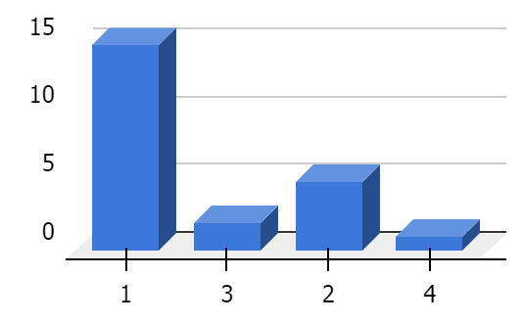

*Diagram 4. 1* Teaching practicum activity doesn't contribute much to my understanding of my teaching abilities or the practical aspects of my future teaching endeavors.

According to the presented data, 65.2% of the students strongly disagree with the statement, 21.7% disagree, 8.7% agree, and 4.3% strongly agree. The majority of students believe that the Teaching practicum activity significantly enhances their teaching skills and prepares them for the practical parts of their future teaching attempts.



*Diagram 4. 2* Teaching practicum activities doesn't provide me with any valuable chances to apply teaching skills*.*

Based on the data that was provided, 39.1% of the students strongly disagree, 52.2% disagree, 4.3% agree, and 4.3% strongly agree with the statement in question. Most students think that the practicum activities provide them worthwhile opportunities to put their teaching abilities into practice.

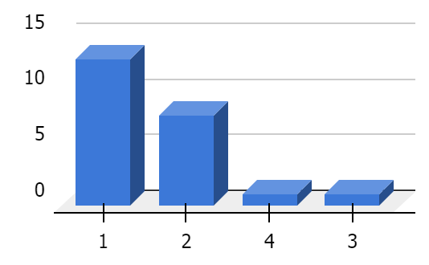

*Diagram 4. 3* Teaching practicum activities don't assist me in identifying my teaching strengths and weaknesses

*.*

56,5% of students strongly disagree, 34,8% disagree, 4,3% agree, and 4.3% strongly agree with the statement, according to the data that was supplied. Most students think that their teaching practicum experiences help them recognize their abilities as well as their weaknesses as educators.

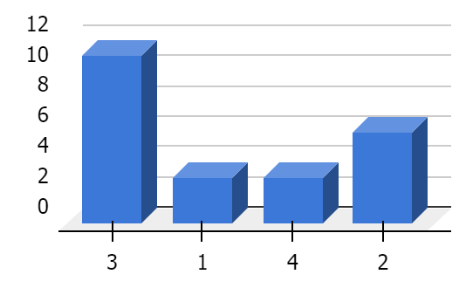

*Diagram 4. 4* During the Teaching Practicum Activity process, I encountered obstacles in costs (material development).

The data that was presented shows that 13% of students strongly disagree, 26.1 % disagree, 47.8% agree, and 13% agree strongly with the statement. Most students acknowledge that they ran into financial Challenges with the Teaching Practicum Activity (material expansion).

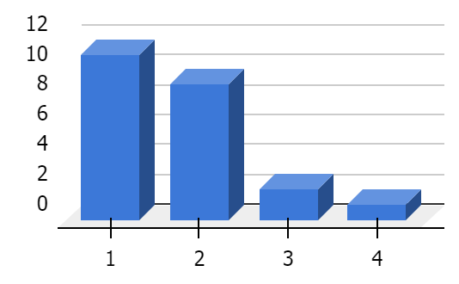

*Diagram 4. 5* Teaching practicum activities don't contribute to learning how to organize my time*.*

Based on the data that was provided, 47.8% of the students strongly disagree, 39.1% disagree, 8.7% agree, and 4.3% strongly agree with the statement. Most students firmly believe that participating in teaching practicum activities helps them improve time management skills.

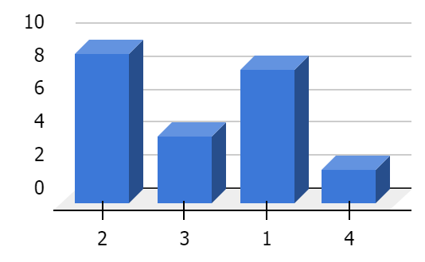

*Diagram 4. 6* Instead of offering practical opportunities to teach a lesson, teaching practicum activities don't help predict classroom problems or enhance my lesson planning*.*

Based on the data that was provided, 34,8% of the students strongly disagree, 39,1% disagree, 17,4% agree, and 8,7% strongly concur with the statement. Most students agree that participating in teaching practicums provides chances for real-world teaching experience and may assist foresee issues that may arise in the classroom or improve lesson preparation.

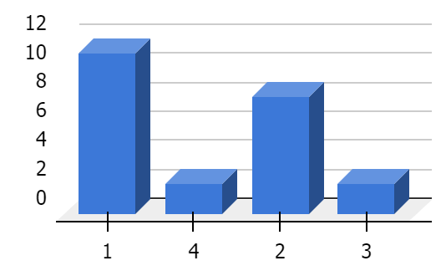

*Diagram 4. 7* Teaching practicum activities don't contribute to an increase in self-confidence in teaching

The data that was provided shows that, of the pupils, 34,8% disagree, 8,7% agree, and 8,7% strongly agree with the statement, while 47,8% strongly disagree. Most students strongly disagree that participating in teaching practicums doesn't help them become more confident teachers.

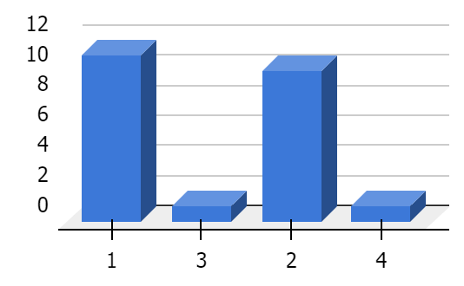

*Diagram 4. 8* Teaching practicum activities don't offer opportunities for meaningful teacher-student communication.

Based on the data that was provided, 34,8% of the students strongly disagree, 43,5% disagree, 13,0% agree, and 8,7% highly agree with the statement. Most students don't believe that there aren't any possibilities for significant teacher-student contact during teaching practicum activities.

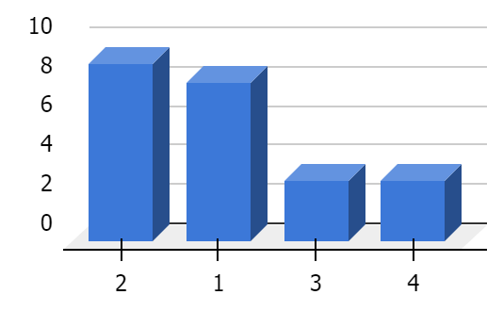

*Diagram 4. 9* Engaging in teaching practicum activities doesn't help me understand the right gestures between students and teachers.

Based on the data that was provided, 34,8% of the students strongly disagree, 32,1% disagree, 13,0% agree, and 13,0% strongly agree with the statement. The majority of students dispute the claim that participating in practicum activities related to teaching doesn’t help them in the understanding of appropriate hand signals between instructors and students.

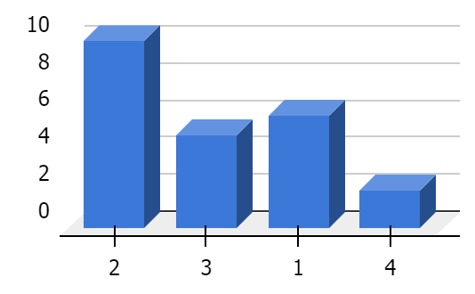

*Diagram 4. 10* Teaching Practicum Activity didn't contribute to the development of appropriate question scores

The data that was provided shows that 26,1% of students strongly disagree, 43,5% disagree, 21,7% agree, and 8,7% strongly agree with the statement. Most students don't believe that the Teaching Practicum Activity didn't help create suitable question scores.

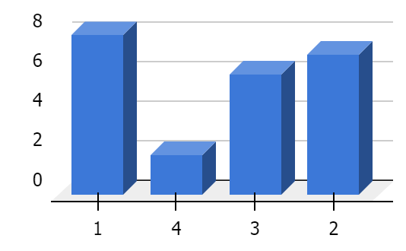

*Diagram 4. 11* Teaching practicum activity doesn't assist me in assessing students' skills

Based on the data that was provided, 34,8% of the students strongly disagree, 30,4% disagree, 26,1% agree, and 8,7% highly agree with the statement. Most students strongly disagree that the teaching practicum does not helps them evaluate students' abilities.

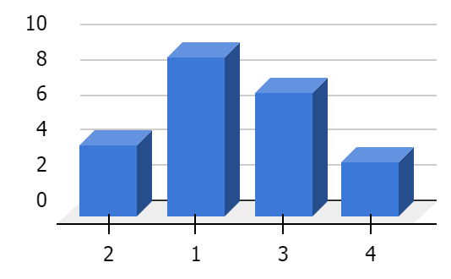

*Diagram 4. 12* Teaching practicum activity doesn't provide techniques to understand the psychological aspects of students.

Based on the data that was provided, 39,1% of the students strongly disagree, 17,4% disagree, 30,4% agree, and 13,0% highly agree with the statement. Most students strongly disagree that the practicum experience does not provide methods for comprehending students' psychological characteristics.

There are some obstacles in the practicum class that are not thought to be difficult, but there are other obstacles in the teaching practicum class that are seen to be difficult, such as the psychological components of the students, the costs of the supplies, and the classroom mannerisms. Noel (2007)

The findings revealed that most students tended to select strongly disagree and disagree in response to the issues they encountered. For example, 13% of students selected encountering costs (material development) as their challenges, and 13% selected understanding the psychological aspects of students.

Table 4. 2

*Score of challenges encountered*

| **No** | **Statements** | **Scale** | **Frequency** | **Score** | |
| --- | --- | --- | --- | --- | --- |
|  | Teaching practicum activity doesn't contribute much to my understanding of my teaching abilities or the practical aspects of my future teaching endeavors.Top of Form | SA (4) | 1 | 4 | |
| A (3) | 2 | 6 | |
| D (2) | 5 | 10 | |
| SD (1) | 15 | 15 | |
|  | Teaching practicum activities doesn't provide me with any valuable chances to apply teaching skills. | SA (4) | 1 | 4 | |
| A (3) | 1 | 3 | |
| D (2) | 12 | 24 | |
| SD (1) | 9 | 9 | |
|  | Teaching practicum activities don't assist me in identifying my teaching strengths and weaknesses. | SA (4) | 1 | 4 | |
| A (3) | 1 | 3 | |
| D (2) | 8 | 16 | |
| SD (1) | 13 | 13 | |
|  | During the Teaching Practicum Activity process, I encountered obstacles in costs (material development). | SA (4) | 3 | 12 | |
| A (3) | 11 | 33 | |
| D (2) | 6 | 12 | |
| SD (1) | 3 | 3 | |
|  | Teaching practicum activities don't contribute to learning how to organize my time. | SA (4) | 1 | 4 | |
| A (3) | 2 | 6 | |
| D (2) | 9 | 18 | |
| SD (1) | 11 | 11 | |
|  | Instead of offering practical opportunities to teach a lesson, teaching practicum activities don't help predict classroom problems or enhance my lesson planning. | SA (4) | 2 | 8 | |
| A (3) | 4 | 12 | |
| D (2) | 9 | 18 | |
| SD (1) | 8 | 8 | |
|  | Teaching practicum activities don't contribute to an increase in self-confidence in teaching | SA (4) | 2 | 8 | |
| A (3) | 2 | 6 | |
| D (2) | 8 | 16 | |
| SD (1) | 11 | 11 | |
|  | Teaching practicum activities don't offer opportunities for meaningful teacher-student communication. | SA (4) | 2 | 8 | |
| A (3) | 3 | 9 | |
| D (2) | 10 | 20 | |
| SD (1) | 8 | 8 | |
|  | Engaging in teaching practicum activities doesn't help me understand the right gestures between students and teachers. | SA (4) | 3 | 12 | |
| A (3) | 3 | 9 | |
| D (2) | 9 | 18 | |
| SD (1) | 8 | 8 | |
|  | Teaching Practicum Activity didn't contribute to the development of appropriate question scores | SA (4) | 2 | 8 | |
| A (3) | 5 | 15 | |
| D (2) | 10 | 20 | |
| SD (1) | 6 | 6 | |
|  | Teaching practicum activity doesn't assist me in assessing students' skills | SA (4) | 2 | 8 | |
| A (3) | 6 | 18 | |
| D (2) | 7 | 14 | |
| SD (1) | 8 | 8 | |
|  | Teaching practicum activity doesn't provide techniques to understand the psychological aspects of students. | SA (4) | 3 | 12 | |
| A (3) | 7 | 21 | |
| D (2) | 4 | 8 | |
| SD (1) | 9 | 9 | |
| **Total** | | | | | **536** |
| **Mean** | | | | | **44,67** |

According to the data shown in the figure above, it is possible to draw the conclusion that the average score for the replies of students to the challenges in teaching practicum class is 44,67, and the total score for the responses is 536.

Table 4. 3

*Factors lead*

| **No** | **Statements** | **Scale** | **Frequency** | **Percentage** |
| --- | --- | --- | --- | --- |
|  | Lack of Experience lead to lack of my understanding with students behaviours | 4 | 14 | 60,9% |
| 3 | 8 | 34,8% |
| 2 | 1 | 4,3% |
| 1 | 0 | 0,0% |
|  | I think my public speaking skill is not good enough | 4 | 4 | 17,4% |
| 3 | 12 | 52,2% |
| 2 | 5 | 21,7% |
| 1 | 2 | 8,7% |
|  | The material I prepared was difficult to apply | 4 | 2 | 8,7% |
| 3 | 4 | 17,4% |
| 2 | 14 | 60,9% |
| 1 | 3 | 13,0% |
|  | The classroom conditions in the Teaching Practicum activity do not fully match the original classroom conditions in the school. | 4 | 12 | 52,2% |
| 3 | 6 | 26,1% |
| 2 | 4 | 17,4% |
| 1 | 1 | 4,3% |
|  | Its hard to teach because insufficient classroom facilities to support material development. | 4 | 5 | 21,7% |
| 3 | 7 | 30,4% |
| 2 | 10 | 43,5% |
| 1 | 1 | 4,3% |

There are a variety of replies to each line of the questionnaire, each of which is tied to a distinct cause that contribute to Challenges in teaching practicum class. As a result, the researcher went through the results in a sequential manner, beginning with the first statement and ending with the last one, as follows:

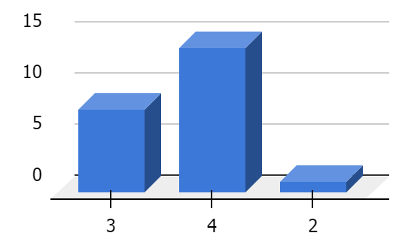

*Diagram 4. 13* I think Lack of Experience lead to lack of my understanding with student.

60% of the students strongly disagree, 34.8% disagree, 4.3% agree, and 0% strongly agree with the given statement, according to the data provided. The general opinion among students is that an absence of experience does not result in a failure to comprehend others.

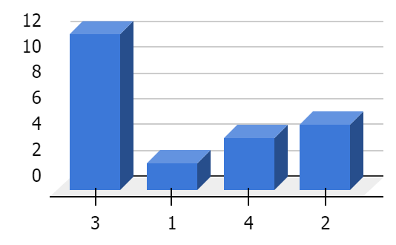

*Diagram 4. 14* I think my public speaking skill is not good enough for teaching practicum class.

17.4% of the students strongly disagree, 52.2% disagree, 21.7% agree, and 8.7% highly agree with the given statement, according to the data provided. The majority of students are not in agreement regarding the belief that their proficiency in public speaking is insufficient to teach a practicum course.

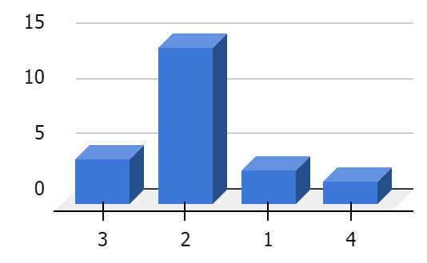

*Diagram 4. 15* The material I prepared for teaching practicum was difficult to apply.

13.0% of students strongly disagree, 60.9% disagree, 17.4% agree, and 8.7% strongly agree with the statement, according to the data that was given. The majority of students dispute the idea that the material that they studied for their teaching practicum was difficult to use.

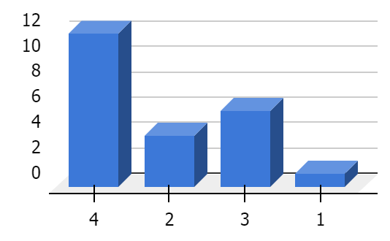

*Diagram 4. 16* The classroom conditions in the Teaching Practicum activity do not fully match the original classroom conditions in the school.

According to the data presented, the statement is highly agreed with by 52,2% of students, 26,1% agree, 17,4% disagree, and 4,3% significantly disagree. The majority of students strongly agree that the classroom settings in the Teaching Practicum activity don't quite correlate to the genuine classroom setup at the school.

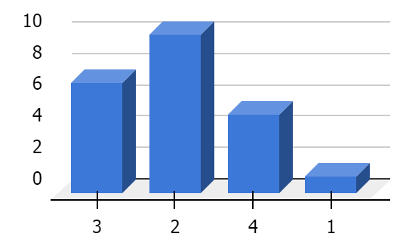

Diagram 4. Its hard to teach because insufficient classroom facilities to support material development*.*

According to the statistics presented, the statement is strongly disagreed with by 4,3% of students, agreed by 30,4%, strongly agreed by 21,7%, and disagreed by 43,5% of students. The majority of pupils dispute the claim that inadequate classroom facilities affect the development of the curriculum.

There are several factors that cause Challenges in teaching practicum classes, including public speaking skills, student behavior, class conditions, lack of understanding of the subject matter. According to Khasinah, Masna & Siregar (2020) students who feel uncomfortable in teaching may use part-time jobs as learning opportunities to hone their skills.

The majority of students selected strongly agree, agree, and disagree as their response choices, according to the data, lack of Experience lead to lack of understanding with student, which is highly agreed with by 60.9% of respondents, and classroom conditions in the teaching practicum activity do not fully match the original classroom conditions in the school with 52.2% of respondents strongly agreeing.

Table 4. 4

*Score of Factors lead*

| **No** | **Statements** | **Scale** | **Frequency** | | **Score** |
| --- | --- | --- | --- | --- | --- |
|  | Lack of Experience lead to lack of my understanding with students behaviours | SA (4) | 14 | | 56 |
| A (3) | 8 | | 24 |
| D (2) | 1 | | 2 |
| SD (1) | 0 | | 0 |
|  | I think my public speaking skill is not good enough | SA (4) | 4 | | 16 |
| A (3) | 12 | | 36 |
| D (2) | 5 | | 10 |
| SD (1) | 2 | | 2 |
|  | The material I prepared was difficult to apply | SA (4) | 2 | | 8 |
| A (3) | 4 | | 12 |
| D (2) | 14 | | 28 |
| SD (1) | 3 | | 3 |
|  | The classroom conditions in the Teaching Practicum activity do not fully match the original classroom conditions in the school. | SA (4) | 12 | | 48 |
| A (3) | 6 | | 18 |
| D (2) | 4 | | 8 |
| SD (1) | 1 | | 1 |
|  | Its hard to teach because insufficient classroom facilities to support material development. | SA (4) | 5 | | 20 |
| A (3) | 7 | | 21 |
| D (2) | 10 | | 20 |
| SD (1) | 1 | | 1 |
| **Total Score** | | | | **334** | | |
| **Mean** | | | | **66,80** | | |

According to the data shown in the figure above, it is possible to draw the conclusion that the average score for the replies of students to the variables that contribute to Challenges in teaching practicum class is 66.80, and the total score for the responses is 334.

## B. Discussion

The research was conducted to find out the research question from this study entitled Investigating Challenges of EFL Students in Teaching Practicum Class. This study's primary research questions are "What challenges do EFL students face when teaching practicum classes?", and "What causes those challenges in teaching practicum classes?".

According to the results of the questionnaire, There are several problems or challenges faced by students in teaching practicum classes, such as lack of experience, material costs, feedback that is difficult to understand, and lack of understanding of the material. Noel (2007) stated that the main concerns of teacher candidates throughout their training were mostly personal, including personality, feelings of worth, commitment, and health. Students also often experience anxiety and nervousness while giving public presentations. According to Howritz (2010), Anxiety is a feeling of tension, unpredictability, and unease that is associated with learning a foreign language—English in particular.

These Challenges can also result from a number of other factors, including aspiring teachers' lack of preparation prior to their teaching experience, complex material that is challenging for both teachers and students to understand, unplanned classroom conditions, and many more factors that can determine a teacher's success or failure. Nuzulia (2018) states that a teacher's success or failure as an educator is related to the aspect of their teaching competence that they believe needs to be reorganized or not. Pre-service English teachers should feel free to reflect on everything connected to their teaching methods based on their views, emotions, and beliefs (theory) before entering the classroom and referring to their practices.

Students may deal with this issue in a number of ways, such as by developing their public speaking skills, learning more about teaching outside of the classroom, completing their lesson plans, and developing a more disciplined attitude and level of devotion. Making engaging lesson plans is also highly beneficial. According to Matafane (2020), instructors have a duty to choose and present engaging content that is relevant to the students' requirements and does not repeat itself. Therefore, they must look for and present engaging or amusing information.

However, the issues that students face have their own answers, which is why the university designed a microteaching practicum course to address these issues and help students grow. The Teaching practicum class course may assist students in developing the professional abilities required of instructors in any kind of educational setting by simulating a classroom. Students get the chance to assess their own teaching abilities, and determine what works and what doesn't in this course. (Habiburrahim, Ardiansyah, & Muluk, 2020)

# CHAPTER 5

**CONCLUSION AND SUGGESTION**

## A. Conclusion

The goal of this research is to investigating the challenges that students in the teaching practicum class experience, and investigating the root causes of those Challenges.

Teaching practicum classes provide a regulated and supportive atmosphere that is conducive to the development of skills, the provision of focused feedback, the efficiency of time, the capacity to adapt, the enhancement of confidence, and the possibility of working together. The aforementioned advantages are only a few of the many advantages that teachers may reap by participating in a teaching practicum. A more effective method that has the potential to enhance instructional strategies and bring about an overall increase in the quality of education is this strategic approach. The teaching practicum is a fantastic innovation that is used in teaching and education programs. It provides prospective instructors with great opportunity to build successful teaching tactics.

This is how English students at the Islamic University of Ar-Raniry Students 2019 academic year feel. Based on the results and discussion in the preceding chapter, it was established that there are several variables that make obstacles occur, such as self-awareness, environment, and material preparedness. The results of the questionnaire, which totaled 536 points with an average of 44,67, show that most students believe that teaching practicum courses presents challenges. Furthermore, the elements that lead to issues such as costs (material development), and understanding the psychological aspects of students. Lack of Experience lead to lack of understanding with student, and classroom conditions in the teaching practicum activity do not fully match the original classroom conditions show an average score of 66.80, with a score of 334.

## B. Suggestion

Following the presentation of the data and the subsequent discussion, the researcher offers a recommendation that has the potential to be beneficial not just for educators and students, but also for other researchers who will be doing study on the same subject:

1. For The Lecturers

The findings of the study will be of assistance to the lecturer in establishing a productive order inside the teaching practicum class. This will ensure that students do not have to face any additional problems that make it tough for them to adjust to the new environment. A part-time teaching program that is considered to have a positive influence on students, lecturers, and universities is something that is desired to be implemented by the institution. In addition, it is hoped that this program will be implemented.

2. For English Student

Because this study is an original testimony from the students themselves, it is guaranteed that this issue will be greatly related to other students who would attend the teaching practicum class. This is because the students came up with this problem themselves. However, there are answers or advantages that can be gained by teaching practicum courses that are very valuable for students. These programs may help students overcome these challenges.

3. For Future Research

These factors may be utilized to do more research on the sorts of effective and acceptable questionnaire questions. There are many questionnaire questions that are based on previous researchers and book sources, and these questions have been evaluated for validity and reliability with regard to their validity and reliability.

Similar research can also be done with different methods such as qualitative methods, or mixed methods. This questionnaire may be used in subsequent research with a bigger sample size in the context of the same topic, which is the Challenges that students have while they are teaching practicum courses.

# REFERENCES

Abir, K., & Jaclene, A. (2012). Methodological Triangulation: An Approach to Understanding Data. *Nurse Researcher, 20*(2).

Arikunto, S. (2010). *Dasar-Dasar Evaluasi Pendidikan Edisi 2*. Jakarta: Bumi Aksara.

Ardiansyah. (2018). *The Correlation Between the Student's Teaching practicum class Grade and Their Teaching Ability During Preservice Teaching.* Skripsi thesis, UIN Ar-Raniry Banda Aceh.

Arsal, Z. (2014). Microteaching and pre-service teachers’ sense of self-efficacy in teaching, *European Journal of Teacher Education*, 37:4, 453-464, DOI: 10.1080/02619768.2014.912627

Baker, G., & Joselit, D. (Eds.). (2022). A Questionnaire on Global Methods. *October*, *180*, 3–80. https://doi.org/10.1162/octo_a_00453

Bilen, K. (2015). Effect of teaching practicum class technique on teacher candidates’ beliefs regarding mathematics teaching. *Procedia-Social and Behavioral Sciences*, *174*, 609-616.

Blomberg, G., Stürmer, K., & Seidel, T. (2011, October). How pre-service teachers observe teaching on video: Effects of viewers’ teaching subjects and the subject of the video. Teaching and Teacher Education, 27(7), 1131–1140. <https://doi.org/10.1016/j.tate.2011.04.008>

Can, V. (2009). A microteaching application on a teaching practice course. *Cypriot Journal of Educational Sciences, 4(*125-140)

Creswell, J. W. (2012). *Research Design: Qualitative, Quantitative and Mixed Approaches (4th Ed).* Thousand Oaks, CA: SAGE.

David, M. (2023, May 10). Slow Learners Vs Fast Learners: Understanding the Difference. Retrieved from <https://www.doassignmenthelp.com/blog/slow-learners-vs-fast-learners/>

Dianna, D. (2020). Analsis Data Kualitatif dan Kuantitatif. *Research Gate*, 1-10.

Dwight W. Allen & Arthur W. Eve (1968) Microteaching, *Theory Into Practice*, 7:5, 181-185, DOI: 10.1080/00405846809542153

Enama, P. R. B. (2021). Student Teachers' Competence in Lesson Planning During Microteaching. *Journal of Teacher Education and Educators*, *10*(3), 341-368.

Gunderson. (2018). Research Methodology and Approaches. *IOSR Journal of Research & Method in Education (IOSR-JRME), 5*(3), 48-51.

Helmiati. (2013). *Teaching practicum class Melatih Keterampilan Dasar Mengajar*. p.22

Hembram, B. (2021). Teaching practicum class: a way to build up teaching skills. *Scholarly Research Journal for Interdisciplinary Studies*, *9*(66), 15401–15413. <https://doi.org/10.21922/srjis.v9i66.6835>

Howritz, J. (2010). New Insights into Language Anxiety: Theory, Research, and Educational Implication. UK: British Library Cataloguing in Publication Data.

İlhan, A. (2009). A study on the effectiveness of peer microteaching in a teacher education program. *Education and Science, 34*(151).

Khasinah, S., Masna, Y., & Siregar, A. (2019). THE PERCEIVED INFLUENCE OF PART-TIME TEACHING ON STUDENTS’PERFORMANCE IN MICRO-TEACHING CLASS. *Englisia: Journal of Language, Education, and Humanities*, *7*(1), 15-25.

KILLIC, A. (2010). Learner-centered teaching practicum class in teacher education. *International Journal of Instruction, 3*(1)

Koross, R. (2016). Teaching practicum class an Efficient Technique for Learning Effective Teaching Skills: Pre-service Teachers. *Perspective. IRA International Journal of Education and Multidisciplinary Studies* (ISSN 2455–2526), 4(2), 289-299. doi: <http://dx.doi.org/10.21013/irajems.v4.n2.p7>

Linman, J. S. (1980). Media and Methods. New Jersey, NJ: CTU Press.

Makafane, T. D. (2020). Student Teachers Challenges in the Preparation and Implementation of Microteaching: The case of the National University of Lesotho. *International Journal of Academic Research in Progressive Education and Development*, *9*(2), 144-157.

Meigawati, H. D. (2016). *The Analysis of Students’ Perceived Problems in Microteaching Class as Depicted in The Students’ Teaching Journals* (Doctoral dissertation, Program Studi Pendidikan Bahasa Inggris FBS-UKSW).

Muluk, S., Habiburrahim, H., & Ardiansyah, A. (2020). Micro-teaching course: Does it affect students' teaching ability? *Englisia: Journal of Language, Education, and Humanities, 7*(2), 143-155.

Munzaki, D. F., Suadah, L., & Risdaneva, R. (2016). Teaching methods used by students of department of English language education of Uin Ar-Raniry in teaching English at English course. *Englisia: Journal of Language, Education, and Humanities, 4*(1), 10-26.

Mutmainnah, A. R. (2018). *Student perception towards microteaching subject by the english education study program of makassar muhammadiyah university.* Makassar Muhammadiyah University

Noel, N. A. (2007). *Problems Faced by Pre-Service and In-Service Teachers during Teaching Practice: A Survey on PKPG ESL,PKPG Science and B.ED TESL Undergraduates in UNIMAS* . Sarawak: Universiti Malaysia Sarawak.

Nugraheni, F. S. A. (2019, December). Learning Challenges in microteaching class: A case study. In *AIP Conference Proceedings* (Vol. 2194, No. 1). AIP Publishing.

Nuzulia, R. (2016). Pre-service Teachers’ Perception on The Reflective Teaching Practice in Micro-teaching Subject of English Language Education Department of Universitas Islam Indonesia.

Okobia, E. O., Augustine, O. E., & Osagie, R. O. (2013). An Analysis of the Perceived Challenges Faced by Student-Teachers during Teaching Practice Excercise. *Journal of Education and Practice*, 4(11), 1-11.

Ogeyik, M.C. (2009). Attitudes of the student teachers in english language teaching programs towards microteaching technique. *English Language Teaching, 2*(3)

Pham Kim, C. (2017). Evaluating student teachers in micro-teaching with analysis of video recording lesson by boris software at vietnam national university. *Социосфера / Sociosphere*, *8*(3), 67–74. <https://doi.org/10.24044/sph.2017.3.9>

Mahmud, I., & Rawshon, S. (2013). Teaching practicum class to improve teaching method: An analysis on students’ perspectives. *IOSR Journal of Research & Method in Education (IOSR-JRME)*, *1*(4), 69-76.

Rahmawati, D. I., & Suhardiyah, M. (2020). Analisis Faktor-Faktor Yang Mempengaruhi Mahasiswa Dalam Pemilihan E-money. *Majalah ekonomi*, *25*(1), 1-11.

Remesh, A. (2013). Microteaching, an efficient technique for learning effective teaching. Retrieved from <https://www.ncbi.nlm.nih.gov/pmc/articles/PMC3724377/>

SAHARDIN, R., HERIANSYAH, H., & YUNIARTI, A. (2020). The obstacles faced by EFL students in the microteaching course. *International Journal of Language Studies*, *14*(4).

Segall, A. (2001). Re-thinking Theory and Practice in the Preservice Teacher Education Classroom: Teaching to learn from learning to teach. *Teaching Education*, *12*(2), 225–242. https://doi.org/10.1080/10476210120068093

Silalahi, D. E. (2020). ENGLISH LESSON PLAN IMPLEMENTATION BY TEACHERS CANDIDATE IN TEACHING PRACTICUM CLASS COURSE AT FKIP OF HKBP NOMMENSEN UNIVERSITY. *Journal of Languages and Language Teaching*, *8*(2), 193. <https://doi.org/10.33394/jollt.v8i2.2542>

Storm, A. (2023, March 24). Thinkific. Retrieved from <https://www.thinkific.com/blog/how-to-make-microteaching-lesson-plan/>

Sugiyono. (2010). *Metode Penelitian Kuantitatif,and Kualitatif*. Alfabeta.

**APPENDICES**

**Appendix A *Appointment Letter of Supervisor***

**Appendix B *Questionnaire Guideline***

Assalamualaikum Wr. Wb. My name is Fathun Mubin Agusni, a student of English Language Education Department of Faculty of Tarbiyah and Teacher Training of UIN Ar-Raniry. I am writing a final project to complete my bachelor degree by conducting a research entitled "INVESTIGATING CHALLENGES OF EFL STUDENTS IN TEACHING PRACTICUM CLASS ".

This questionnaire contains 17 questions regarding the challenges faced by PBI batch 19 students when undergoing teaching practicum classes. The questions in this questionnaire come from previous research, books and journals. The questionnaire is divided into 2 section, namely Problems encountered, and Factors lead. The questionnaire will be distributed via google form, the estimated time required to fill out this questionnaire is 10-15 minutes.

Instruction:

1. Students are required to fill in their name and ID number in the initial section of the Google form.
2. In the next session, there is a statement regarding the Challenges they faced during the teaching practicum class, students are required to choose 1 answer option listed.
3. The answer options consist of Strongly Agree (SA), Agree (A), Disagree (D), and Strongly Disagree (SD).
4. Choose the Strongly Agree (SA) answer if the situation is considered to really describe the situation in the teaching practicum class.
5. Choose the Agree (A) answer if the situation is considered to adequately describe the situation of the teaching practicum class.
6. Choose the Disagree answer (D) if the situation is deemed not to adequately describe the condition of the teaching practicum class.
7. Choose the answer Strongly Disagree (SD) if the situation is considered very not likely to describe the situation of the teaching practicum class.
8. Students are required to fill in all available questions before they can proceed to the next section
9. After completing all the questions, the completed questionnaire ends, the data will be automatically submitted to the author's Google Drive.

I would like to thank you very much for helping me by filling out the questionnaire honestly.

Best regards,

The researcher,

Fathun Mubin Agusni

**Appendix C *List of Questionnaire***

|  |  |  |
| --- | --- | --- |
| **NO** | **Sub** | **Statements** |
|  | **Challenges encountered** | Teaching practicum activity doesn't contribute much to my understanding of my teaching abilities or the practical aspects of my future teaching endeavors.Top of Form |
|  | Teaching practicum activities doesn't provide me with any valuable chances to apply teaching skills. |
|  | Teaching practicum activities don't assist me in identifying my teaching strengths and weaknesses. |
|  | During the Teaching Practicum Activity process, I encountered obstacles in costs (material development). |
|  | Teaching practicum activities don't contribute to learning how to organize my time. |
|  | Instead of offering practical opportunities to teach a lesson, teaching practicum activities don't help predict classroom problems or enhance my lesson planning. |
|  | Teaching practicum activities don't contribute to an increase in self-confidence in teaching |
|  | Teaching practicum activities don't offer opportunities for meaningful teacher-student communication. |
|  | Engaging in teaching practicum activities doesn't help me understand the right gestures between students and teachers. |
|  | Teaching Practicum Activity didn't contribute to the development of appropriate question scores |
|  | Teaching practicum activity doesn't assist me in assessing students' skills |
|  | Teaching practicum activity doesn't provide techniques to understand the psychological aspects of students. |
|  | **Factors lead** | Lack of Experience lead to lack of my understanding with students behaviours |
|  | I think my public speaking skill is not good enough |
|  | The material I prepared was difficult to apply |
|  | The classroom conditions in the Teaching Practicum activity do not fully match the original classroom conditions in the school. |
|  | Insufficient classroom facilities to support material development |

**Appendix D *Form of Questionnaire.***

**Appendix E *Result of Questionnaire.***

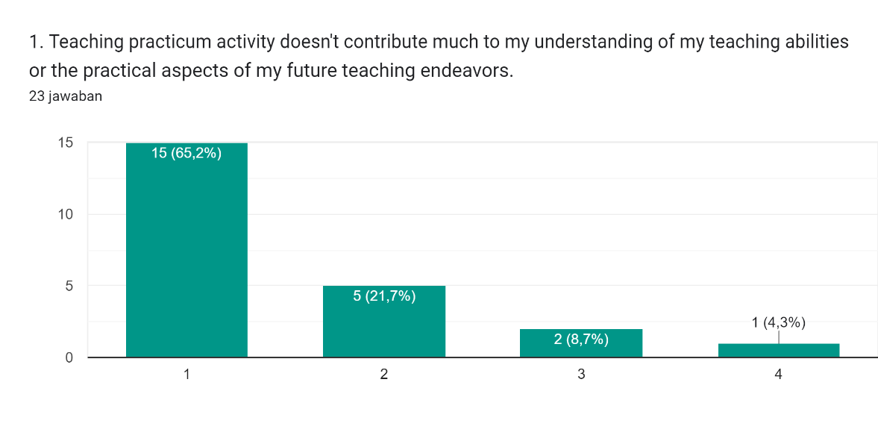 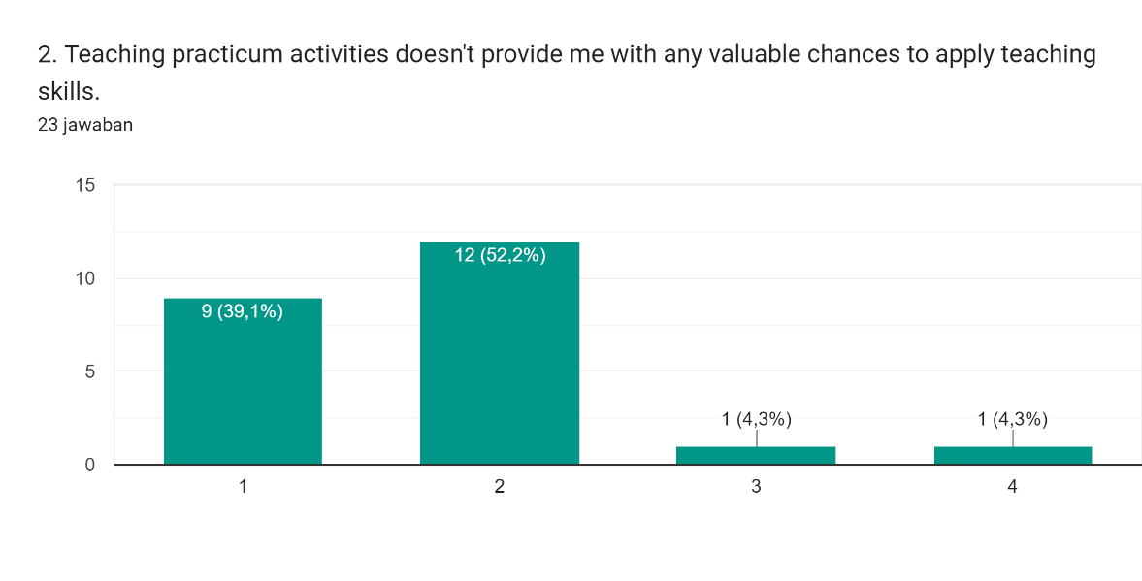 Diagram jawaban Formulir. Judul pertanyaan: 3. Teaching practicum activities don&apos;t assist me in identifying my teaching strengths and weaknesses.
. Jumlah jawaban: 23 jawaban. Diagram jawaban Formulir. Judul pertanyaan: 4. During the Teaching Practicum Activity process, I encountered obstacles in costs (material development).
. Jumlah jawaban: 23 jawaban. Diagram jawaban Formulir. Judul pertanyaan: 5. Teaching practicum activities don&apos;t contribute to learning how to organize my time.
. Jumlah jawaban: 23 jawaban. 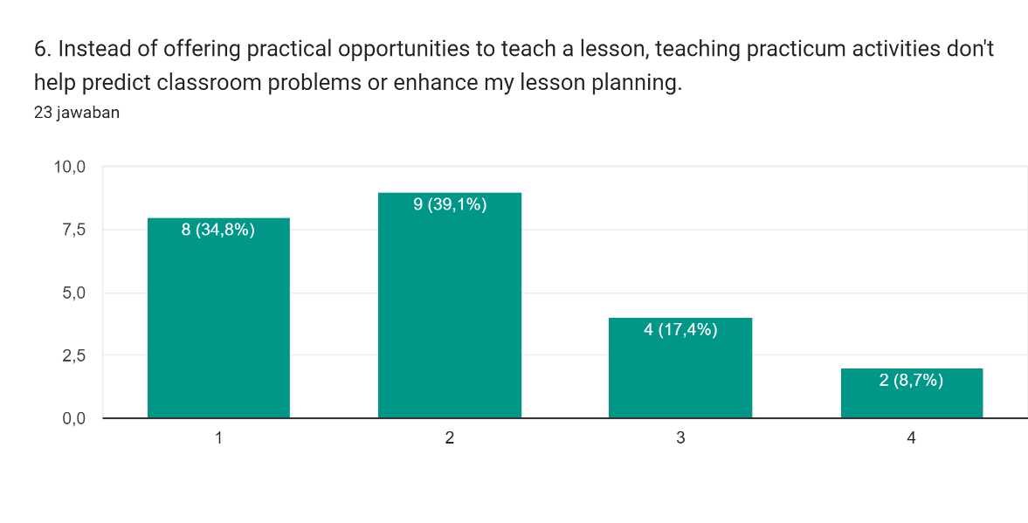 Diagram jawaban Formulir. Judul pertanyaan: 7. Teaching practicum activities don&apos;t contribute to an increase in self-confidence in teaching
. Jumlah jawaban: 23 jawaban.Diagram jawaban Formulir. Judul pertanyaan: 8. Teaching practicum activities don&apos;t offer opportunities for meaningful teacher-student communication.
. Jumlah jawaban: 23 jawaban.Diagram jawaban Formulir. Judul pertanyaan: 9. Engaging in teaching practicum activities doesn&apos;t help me understand the right gestures between students and teachers.
. Jumlah jawaban: 23 jawaban.Diagram jawaban Formulir. Judul pertanyaan: 10. Teaching Practicum Activity didn&apos;t contribute to the development of appropriate question scores
. Jumlah jawaban: 23 jawaban.Diagram jawaban Formulir. Judul pertanyaan: 11. Teaching practicum activity doesn&apos;t assist me in assessing students&apos; skills
. Jumlah jawaban: 23 jawaban.Diagram jawaban Formulir. Judul pertanyaan: 12. Teaching practicum activity doesn&apos;t provide techniques to understand the psychological aspects of students.
. Jumlah jawaban: 23 jawaban.Diagram jawaban Formulir. Judul pertanyaan: 13. I think Lack of Experience lead to lack of my understanding with student.
. Jumlah jawaban: 23 jawaban.Diagram jawaban Formulir. Judul pertanyaan: 14. I think my public speaking skill is not good enough for teaching practicum class
. Jumlah jawaban: 23 jawaban.Diagram jawaban Formulir. Judul pertanyaan: 15. The material I prepared for teaching practicum was difficult to apply
. Jumlah jawaban: 23 jawaban.Diagram jawaban Formulir. Judul pertanyaan: 16. The classroom conditions in the Teaching Practicum activity do not fully match the original classroom conditions in the school.
. Jumlah jawaban: 23 jawaban.Diagram jawaban Formulir. Judul pertanyaan: 17. its hard to teach because insufficient classroom facilities to support material development
. Jumlah jawaban: 23 jawaban.

**Appendix F *Responses of Participant***

